Open Path

1. Definition
# Source: AI Source: Provided by: [Data Path: Persons Table -> ID Column: 1, Name_En Column: Motasem Essam] -> From: [ChatGPT] on [7/25/2026]
An Open Path is a geometric path whose starting point and ending point are different.
If a path starts at $A$and ends at $B$, then:
$$\boxed{A≠B}$$
Equivalently, for a parameterized path $r\left(t\right)$defined on $\left[a , b\right]$:
$$\boxed{r\left(a\right)≠r\left(b\right)}$$
An open path does not return to its starting point.
Simple Definition
An Open Path is a path that has a distinct starting point and ending point.

2. Main Classification
# Source: AI Source: Provided by: [Data Path: Persons Table -> ID Column: 1, Name_En Column: Motasem Essam] -> From: [ChatGPT] on [7/25/2026]
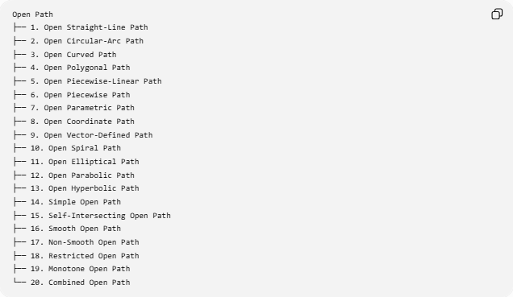
Open Path
├── 1. Open Straight-Line Path
├── 2. Open Circular-Arc Path
├── 3. Open Curved Path
├── 4. Open Polygonal Path
├── 5. Open Piecewise-Linear Path
├── 6. Open Piecewise Path
├── 7. Open Parametric Path
├── 8. Open Coordinate Path
├── 9. Open Vector-Defined Path
├── 10. Open Spiral Path
├── 11. Open Elliptical Path
├── 12. Open Parabolic Path
├── 13. Open Hyperbolic Path
├── 14. Simple Open Path
├── 15. Self-Intersecting Open Path
├── 16. Smooth Open Path
├── 17. Non-Smooth Open Path
├── 18. Restricted Open Path
├── 19. Monotone Open Path
└── 20. Combined Open Path

1. Open Straight-Line Path
# Source: AI Source: Provided by: [Data Path: Persons Table -> ID Column: 1, Name_En Column: Motasem Essam] -> From: [ChatGPT] on [7/25/2026]
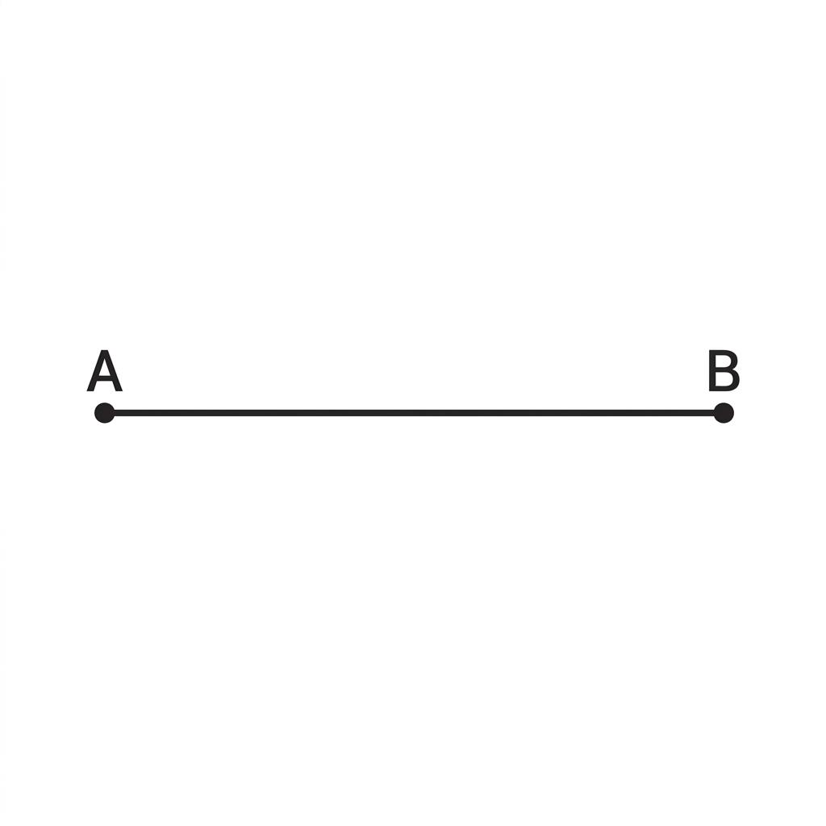
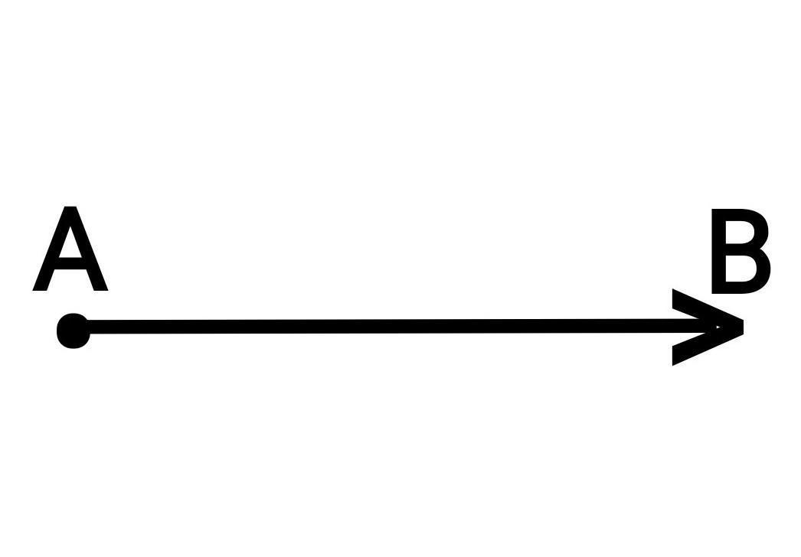

An Open Straight-Line Path is a straight path whose starting and ending points are different.
$$A≠B$$
For a finite path:
$$\boxed{P=\overset{‾}{AB}}$$
Example
A point moves directly from
$$A=\left(1 , 2\right)$$
to
$$B=\left(6 , 5\right).$$
The path is an open straight-line path.
Important Property
It is the shortest path between its two endpoints:
$$\boxed{L=AB}$$

2. Open Circular-Arc Path
# Source: AI Source: Provided by: [Data Path: Persons Table -> ID Column: 1, Name_En Column: Motasem Essam] -> From: [ChatGPT] on [7/25/2026]
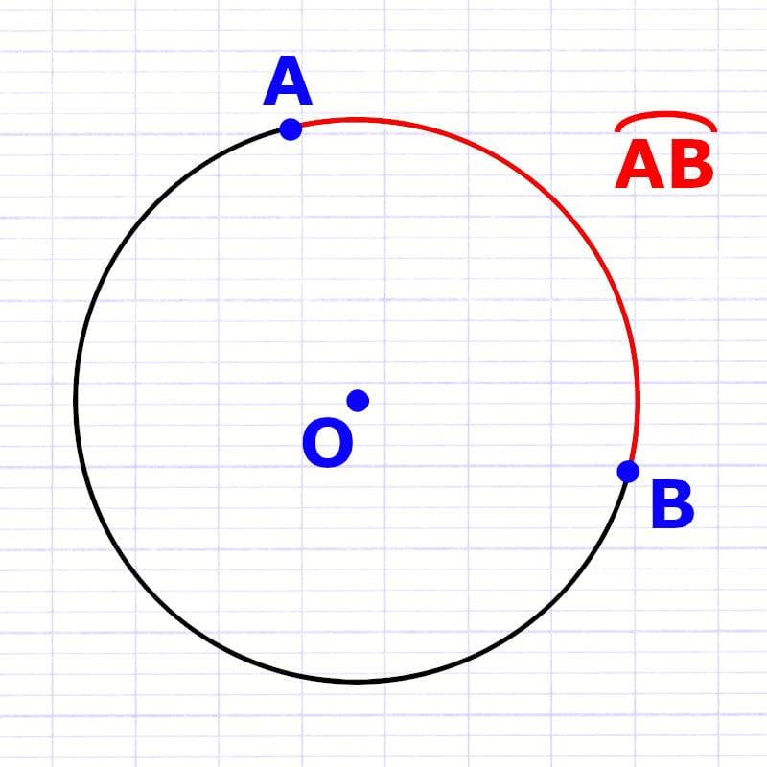
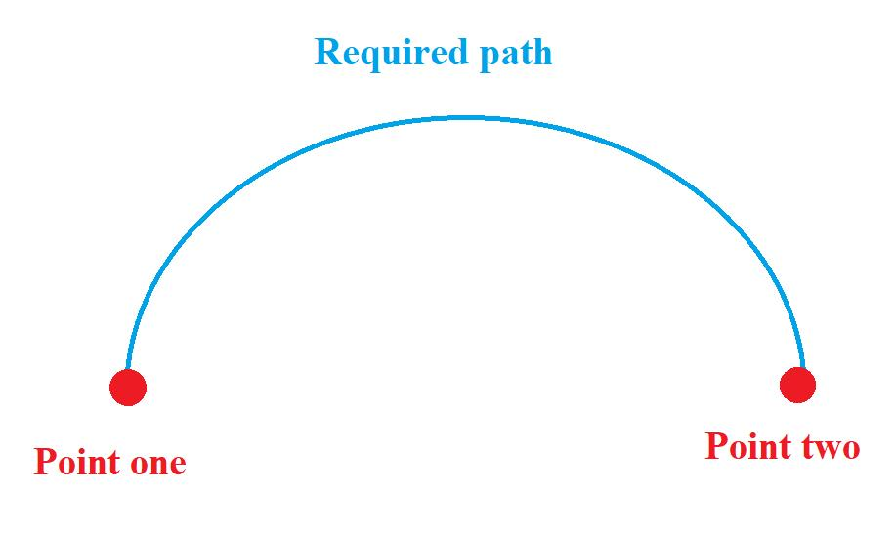
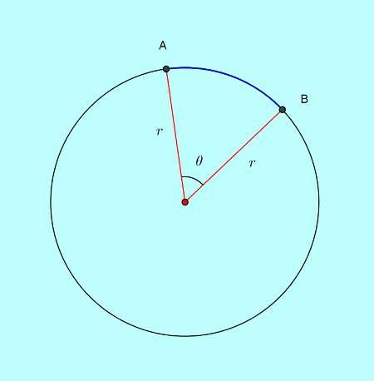
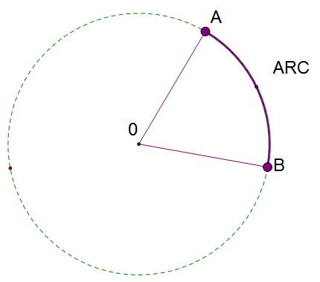
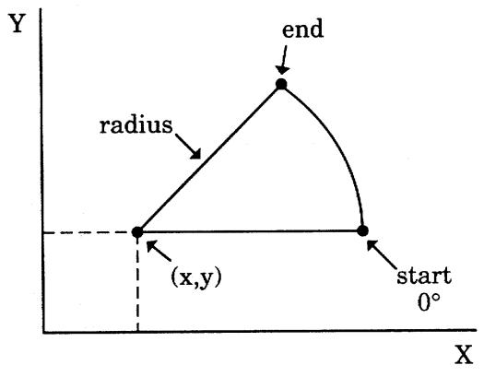
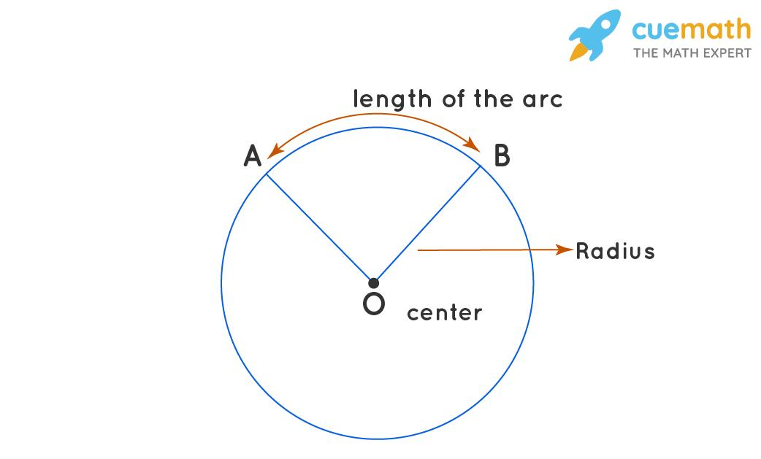
An Open Circular-Arc Path is a portion of a circle whose endpoints are distinct.
$$A≠B$$
For a circle centered at $O$:
$$OA=OB=r.$$
Example
A point travels from $A$to $B$along a quarter-circle.
The path does not return to $A$, so it is open.
Arc Length
$$\boxed{s=rθ}$$
where $θ$is in radians.

3. Open Curved Path
# Source: AI Source: Provided by: [Data Path: Persons Table -> ID Column: 1, Name_En Column: Motasem Essam] -> From: [ChatGPT] on [7/25/2026]
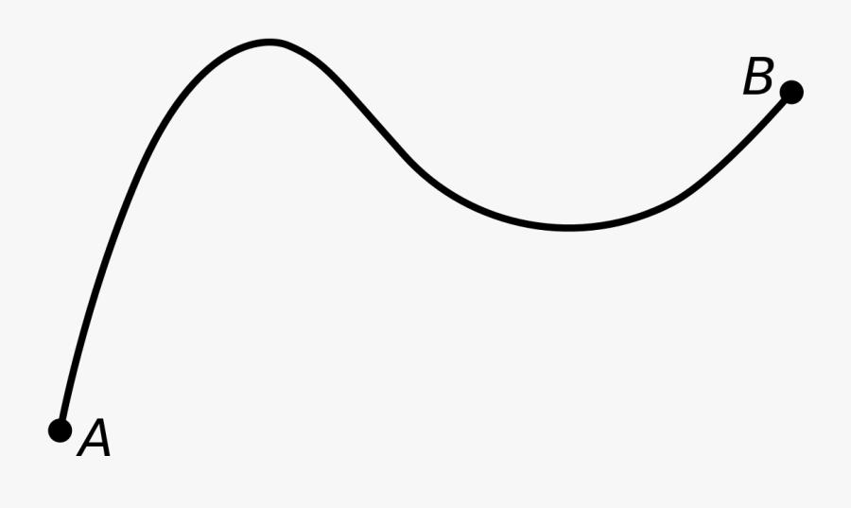
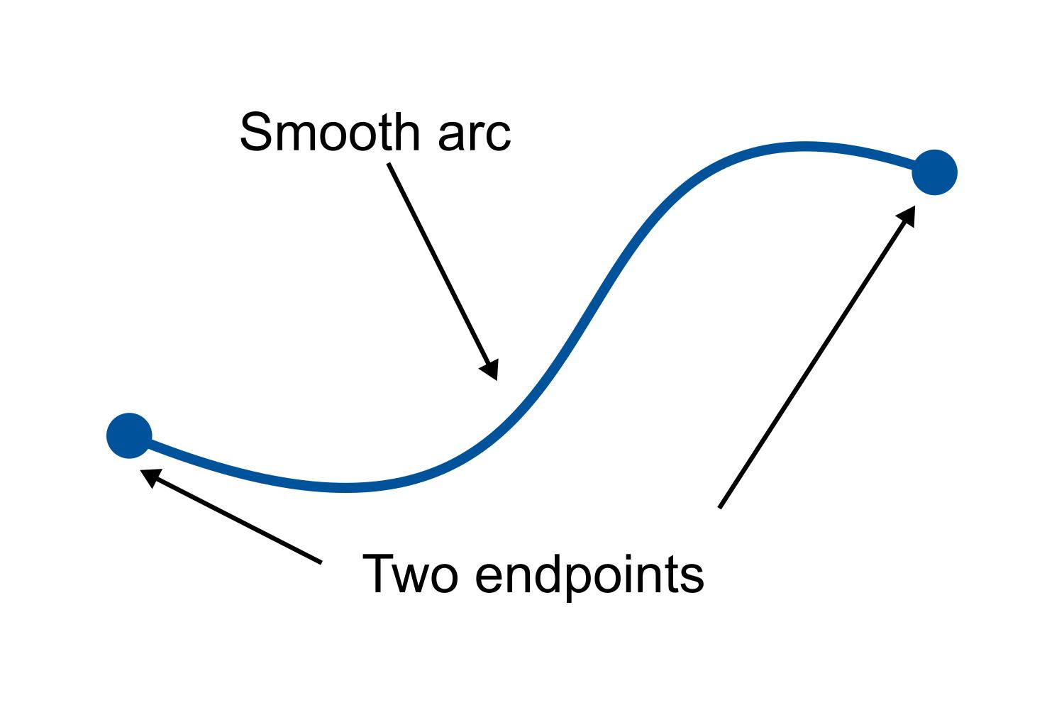
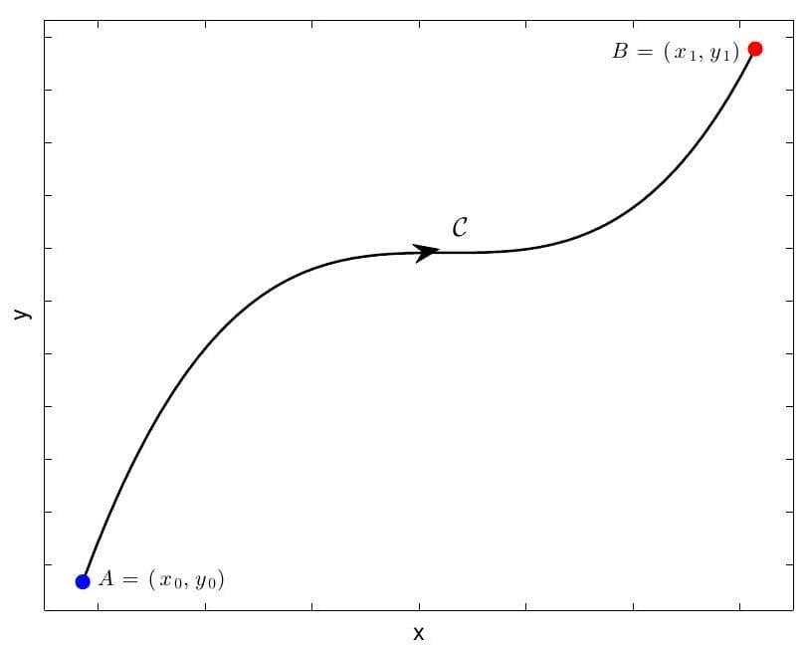
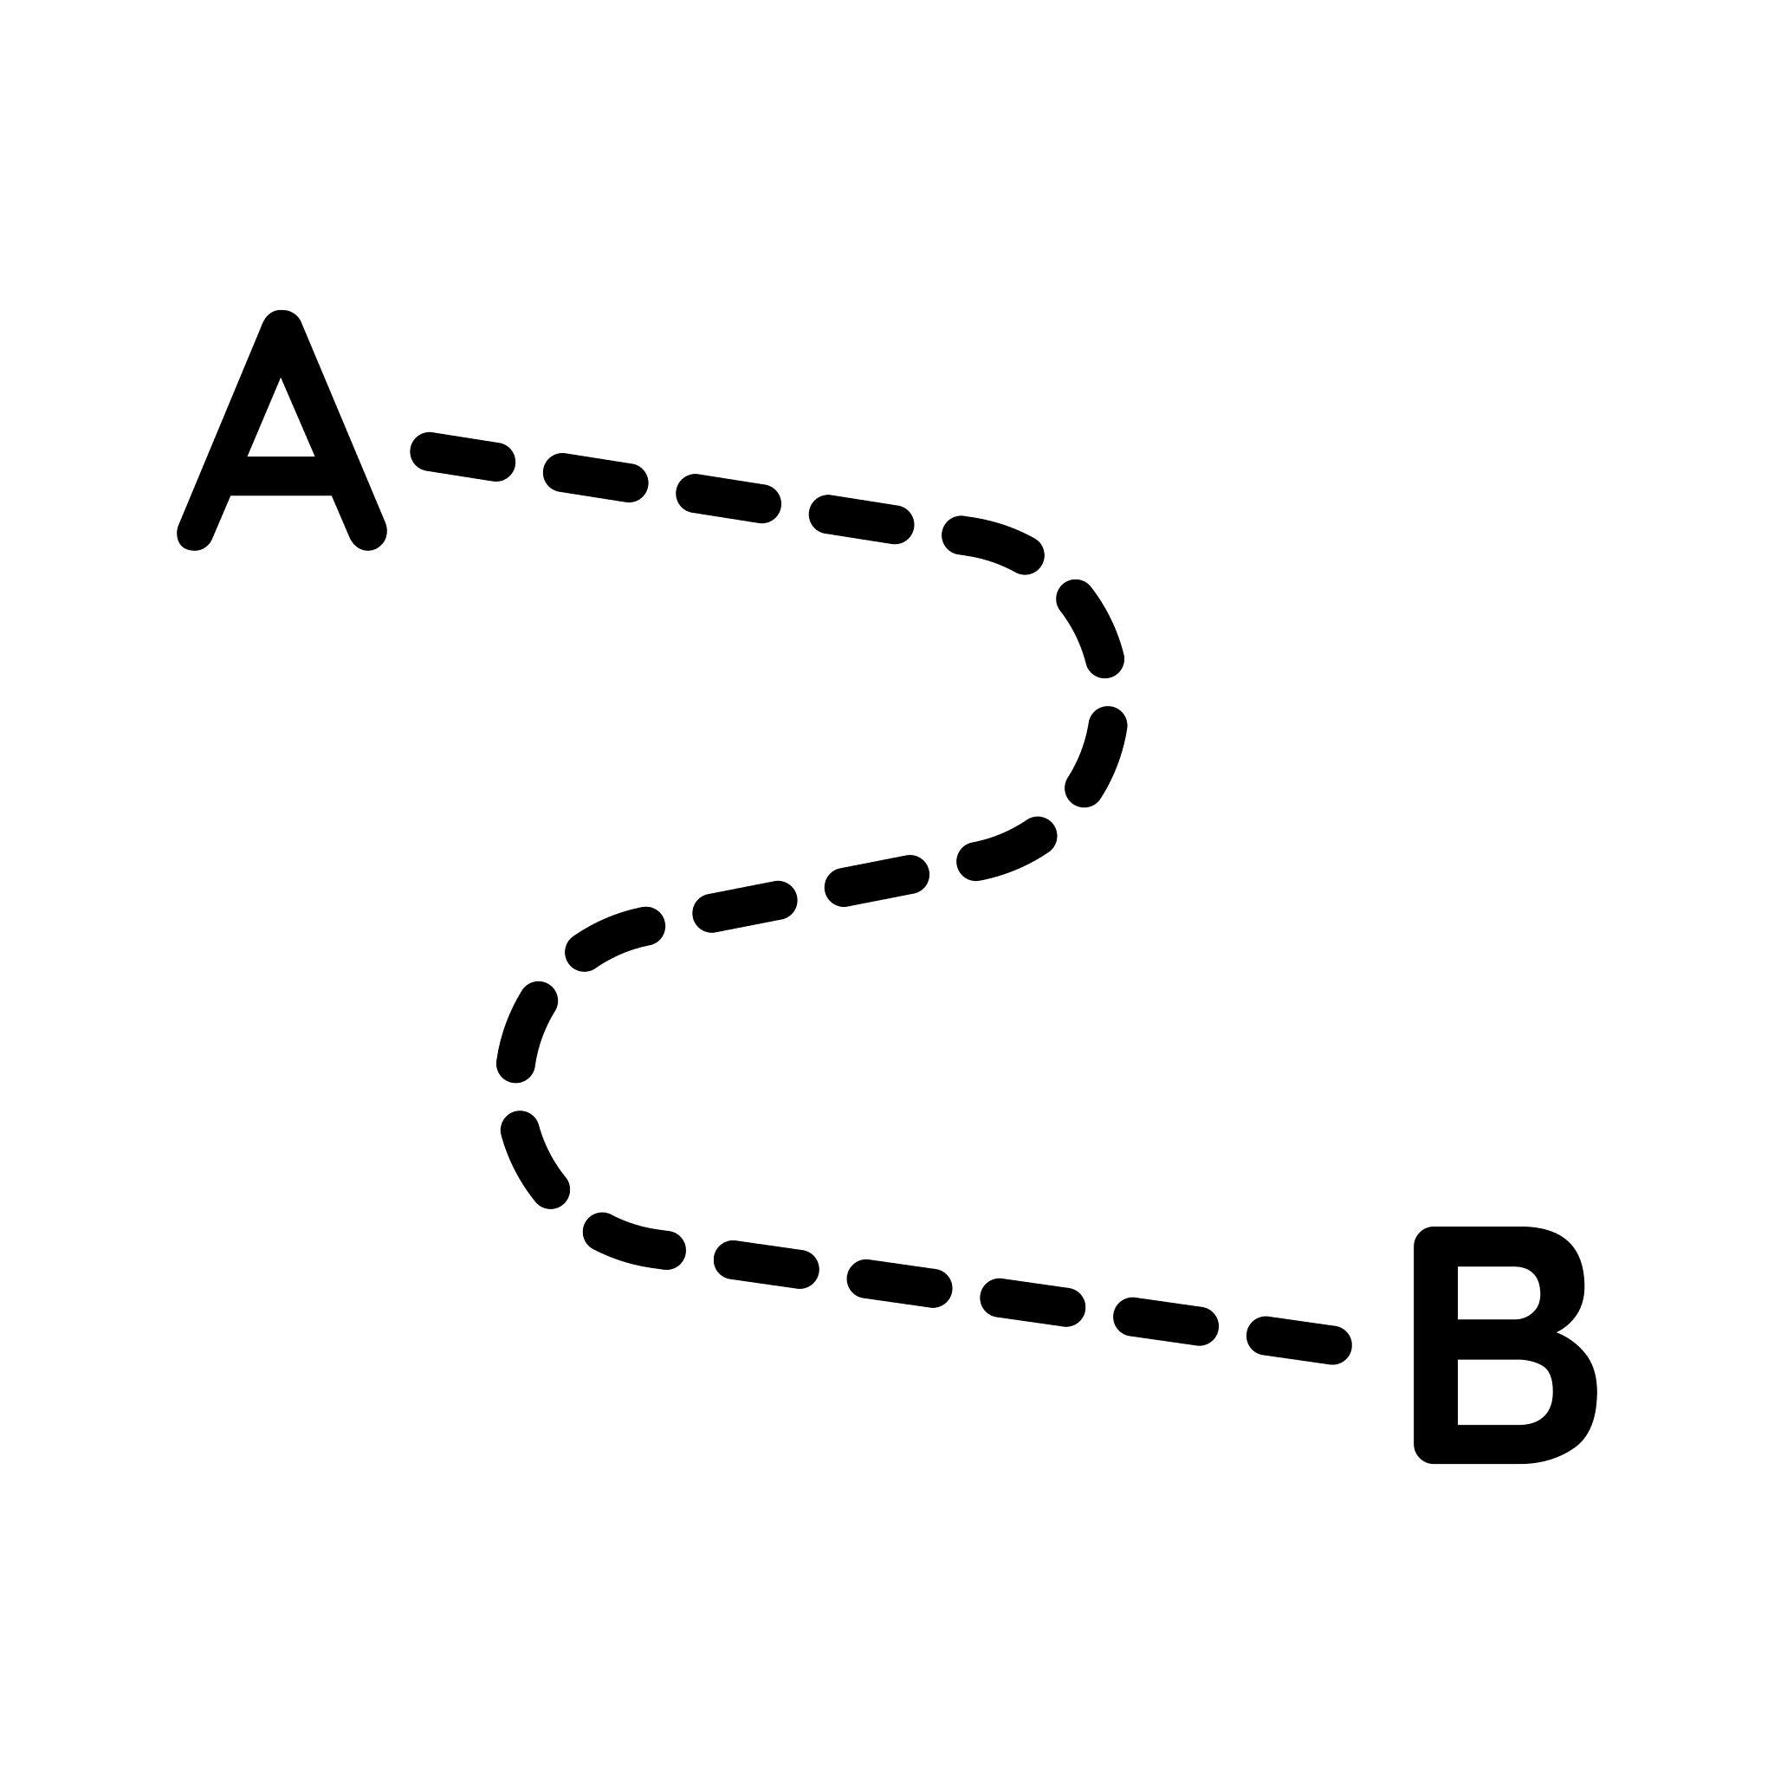
An Open Curved Path follows a curve while having distinct endpoints.
$$\boxed{P_{\text{start}}≠P_{\text{end}}}$$
Example
The path
$$y=x^{2}, 0≤x≤3$$
is an open curved path.
Its endpoints are:
$$\left(0 , 0\right)$$
and
$$\left(3 , 9\right).$$

4. Open Polygonal Path
# Source: AI Source: Provided by: [Data Path: Persons Table -> ID Column: 1, Name_En Column: Motasem Essam] -> From: [ChatGPT] on [7/25/2026]
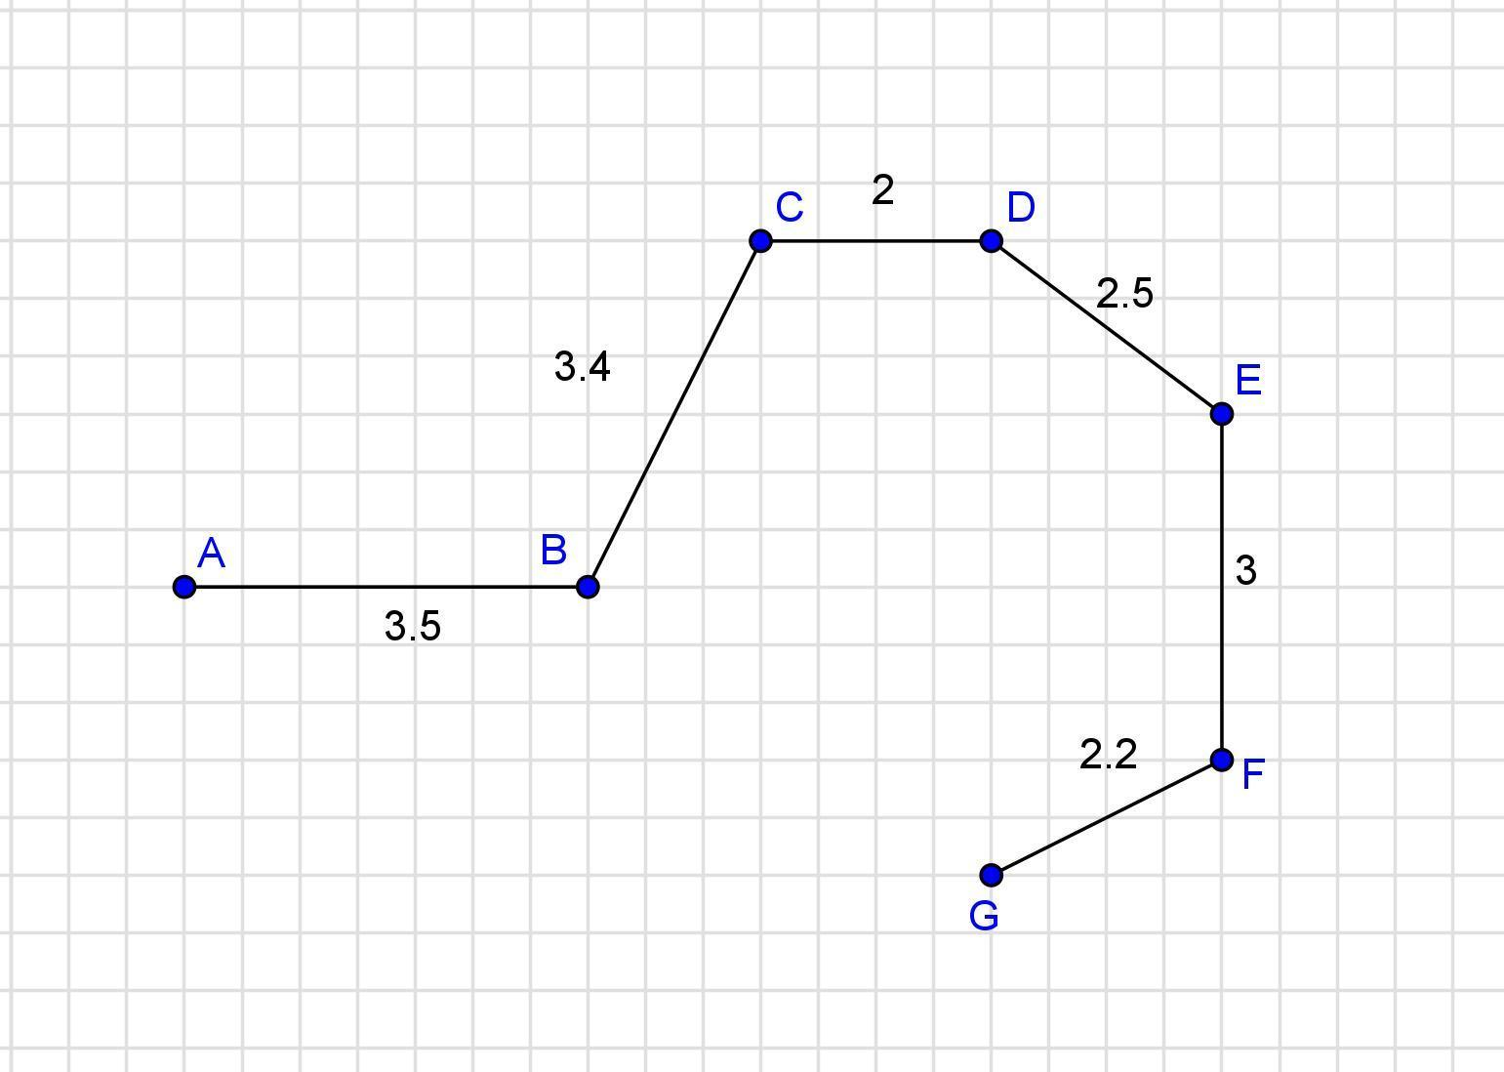
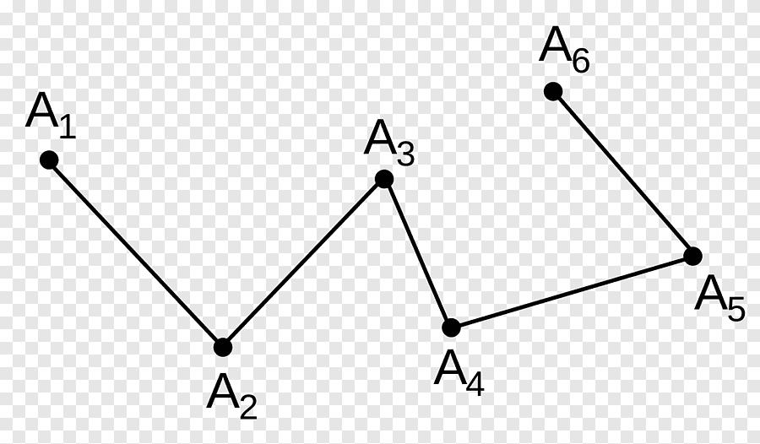
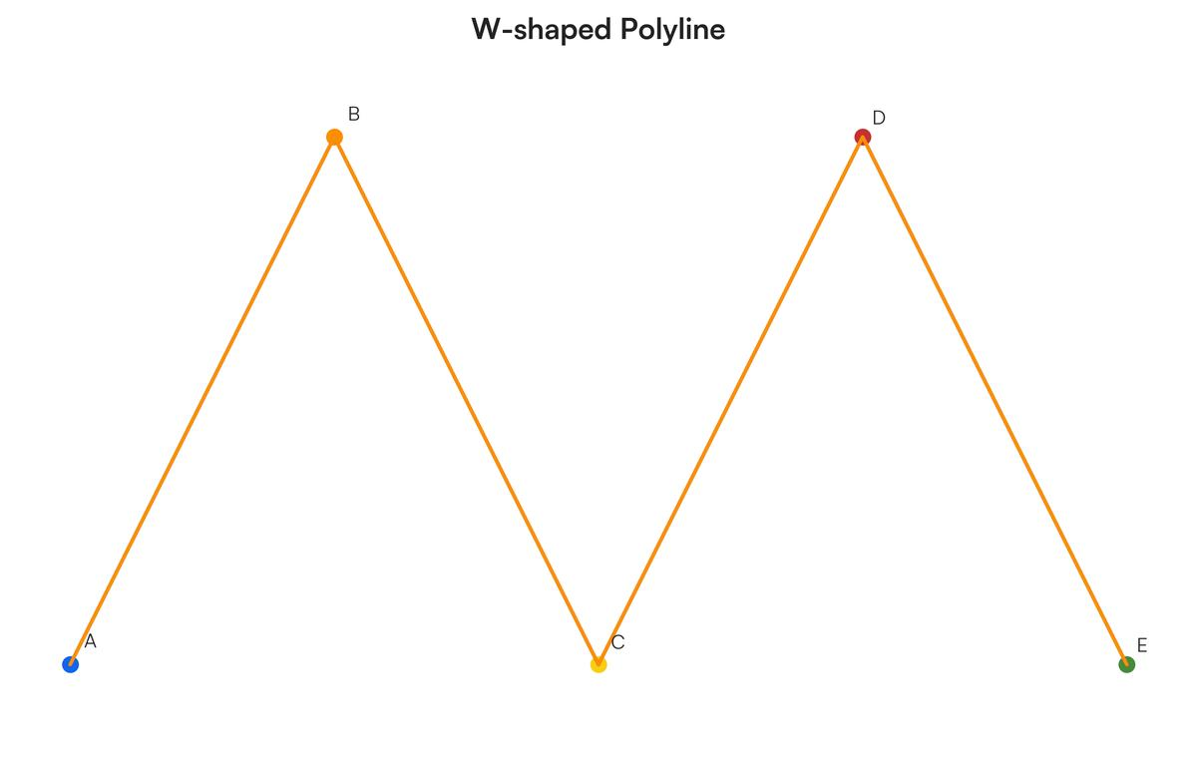
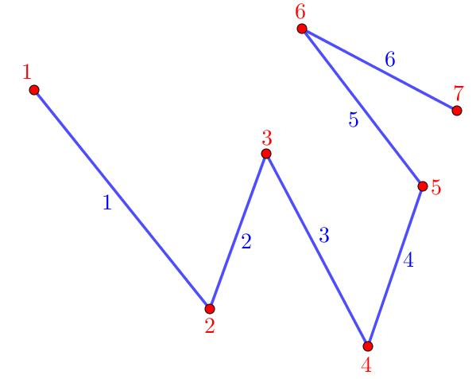
An Open Polygonal Path consists of connected line segments and has different starting and ending vertices.
$$\boxed{P_{0}≠P_{n}}$$
It can be written as:
$$P=\overset{‾}{P_{0}P_{1}}∪\overset{‾}{P_{1}P_{2}}∪⋯∪\overset{‾}{P_{n-1}P_{n}}.$$
Example
$$A→B→C→D$$
where
$$A≠D.$$
The path is open.

5. Open Piecewise-Linear Path
# Source: AI Source: Provided by: [Data Path: Persons Table -> ID Column: 1, Name_En Column: Motasem Essam] -> From: [ChatGPT] on [7/25/2026]
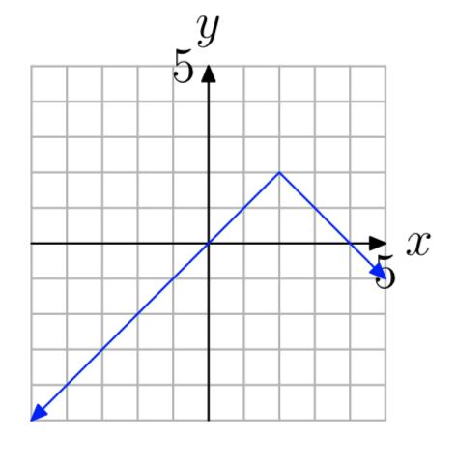
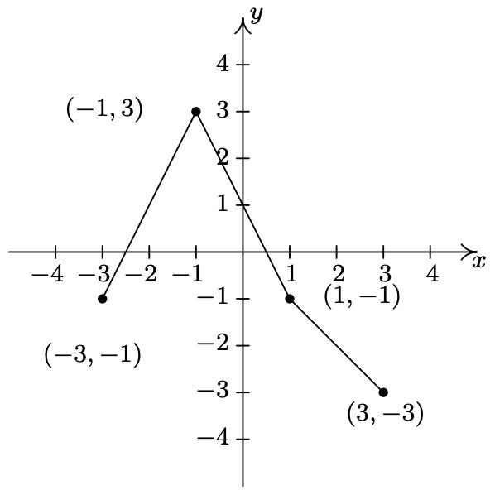
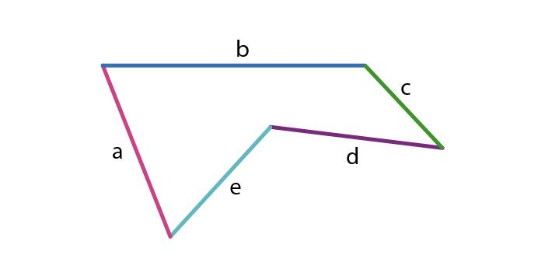
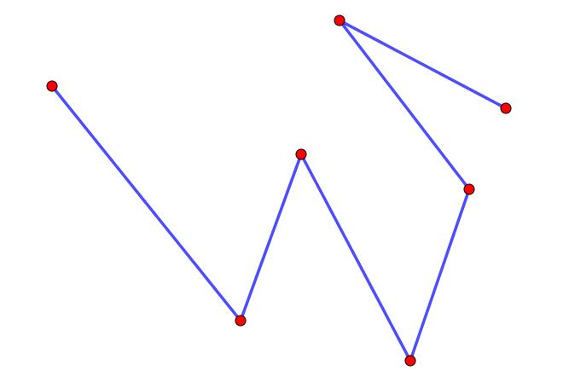
An Open Piecewise-Linear Path is composed of several connected straight-line pieces and has distinct endpoints.
$$\boxed{P_{0}≠P_{n}}$$
Example
$$A→B→C→D$$
with each connection being a straight segment.
This is essentially an open polygonal path.
$$\boxed{\text{Open Polygonal Path}≈\text{Open Piecewise-Linear Path}}$$

6. Open Piecewise Path
# Source: AI Source: Provided by: [Data Path: Persons Table -> ID Column: 1, Name_En Column: Motasem Essam] -> From: [ChatGPT] on [7/25/2026]
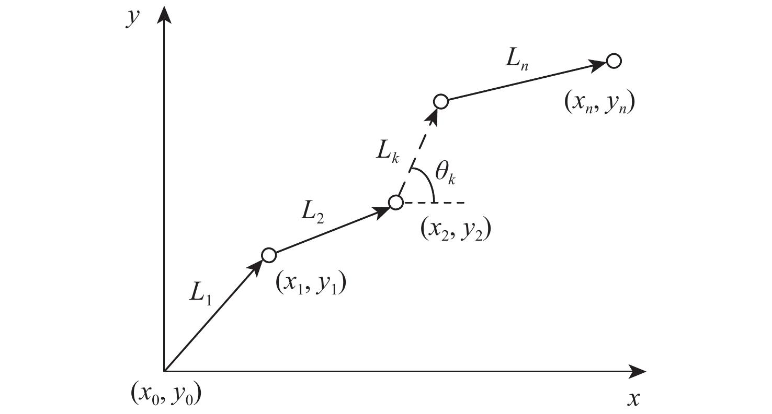
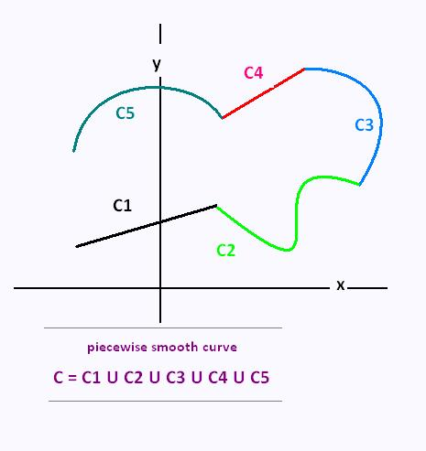
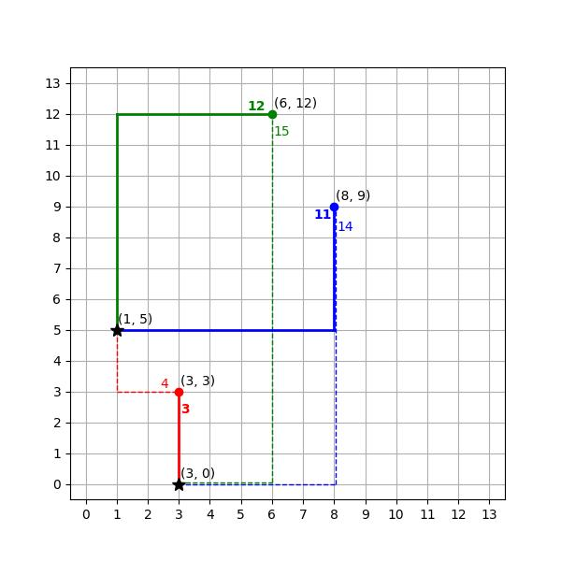
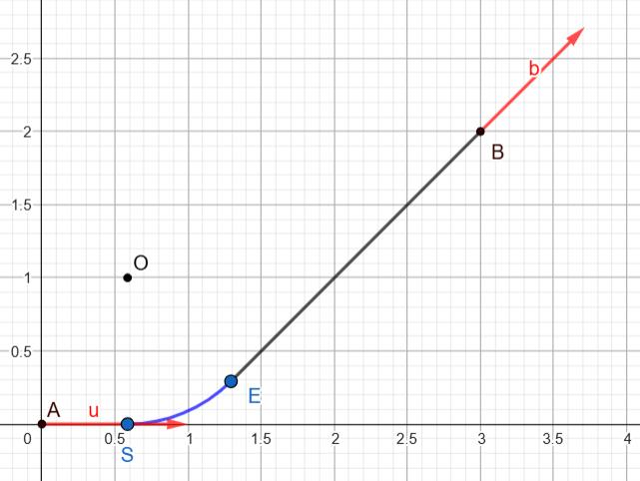
An Open Piecewise Path consists of multiple connected pieces that can have different geometric forms.
For example:
$$\boxed{\text{Straight Segment}→\text{Circular Arc}→\text{Straight Segment}}$$
with different beginning and ending points.
Example
$$A→B$$
along a straight segment, then
$$B→C$$
along a circular arc.
Since $A≠C$, the overall path is open.

7. Open Parametric Path
# Source: AI Source: Provided by: [Data Path: Persons Table -> ID Column: 1, Name_En Column: Motasem Essam] -> From: [ChatGPT] on [7/25/2026]
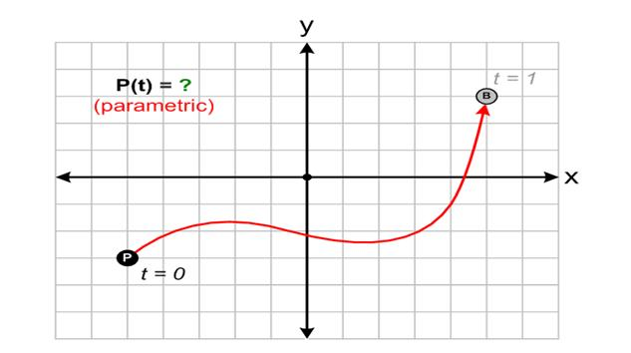
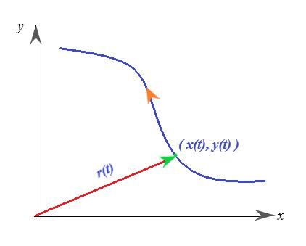
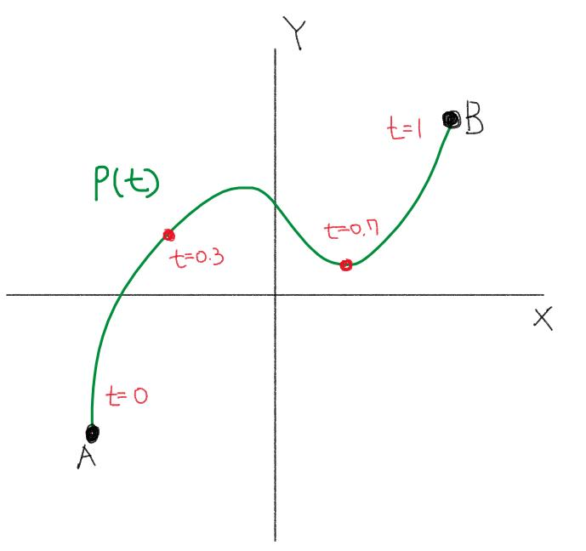
An Open Parametric Path is described parametrically over an interval where the initial and final positions are different.
$$\boxed{r\left(a\right)≠r\left(b\right)}$$
Example
$$r\left(t\right)=\left\langle t , t^{2}\right\rangle , 0≤t≤2.$$
The endpoints are:
$$r\left(0\right)=\left(0 , 0\right)$$
and
$$r\left(2\right)=\left(2 , 4\right).$$
Therefore, the path is open.

8. Open Coordinate Path
# Source: AI Source: Provided by: [Data Path: Persons Table -> ID Column: 1, Name_En Column: Motasem Essam] -> From: [ChatGPT] on [7/25/2026]
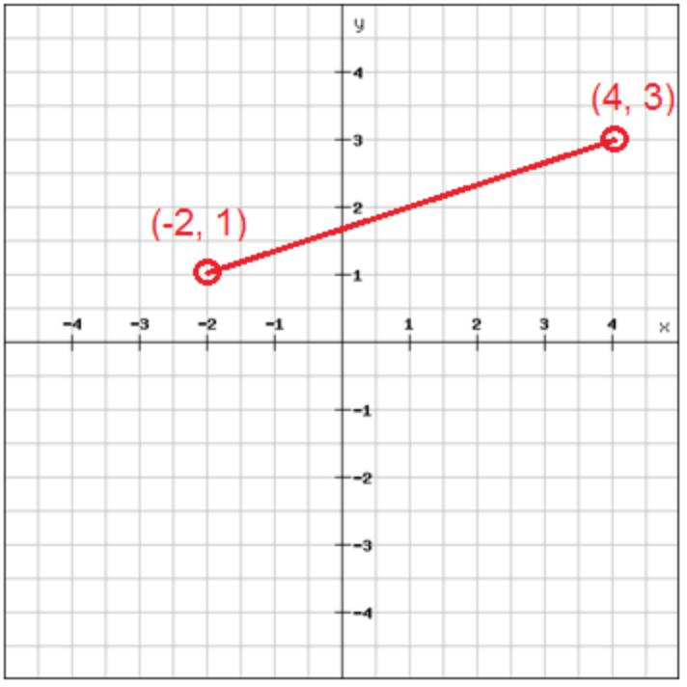
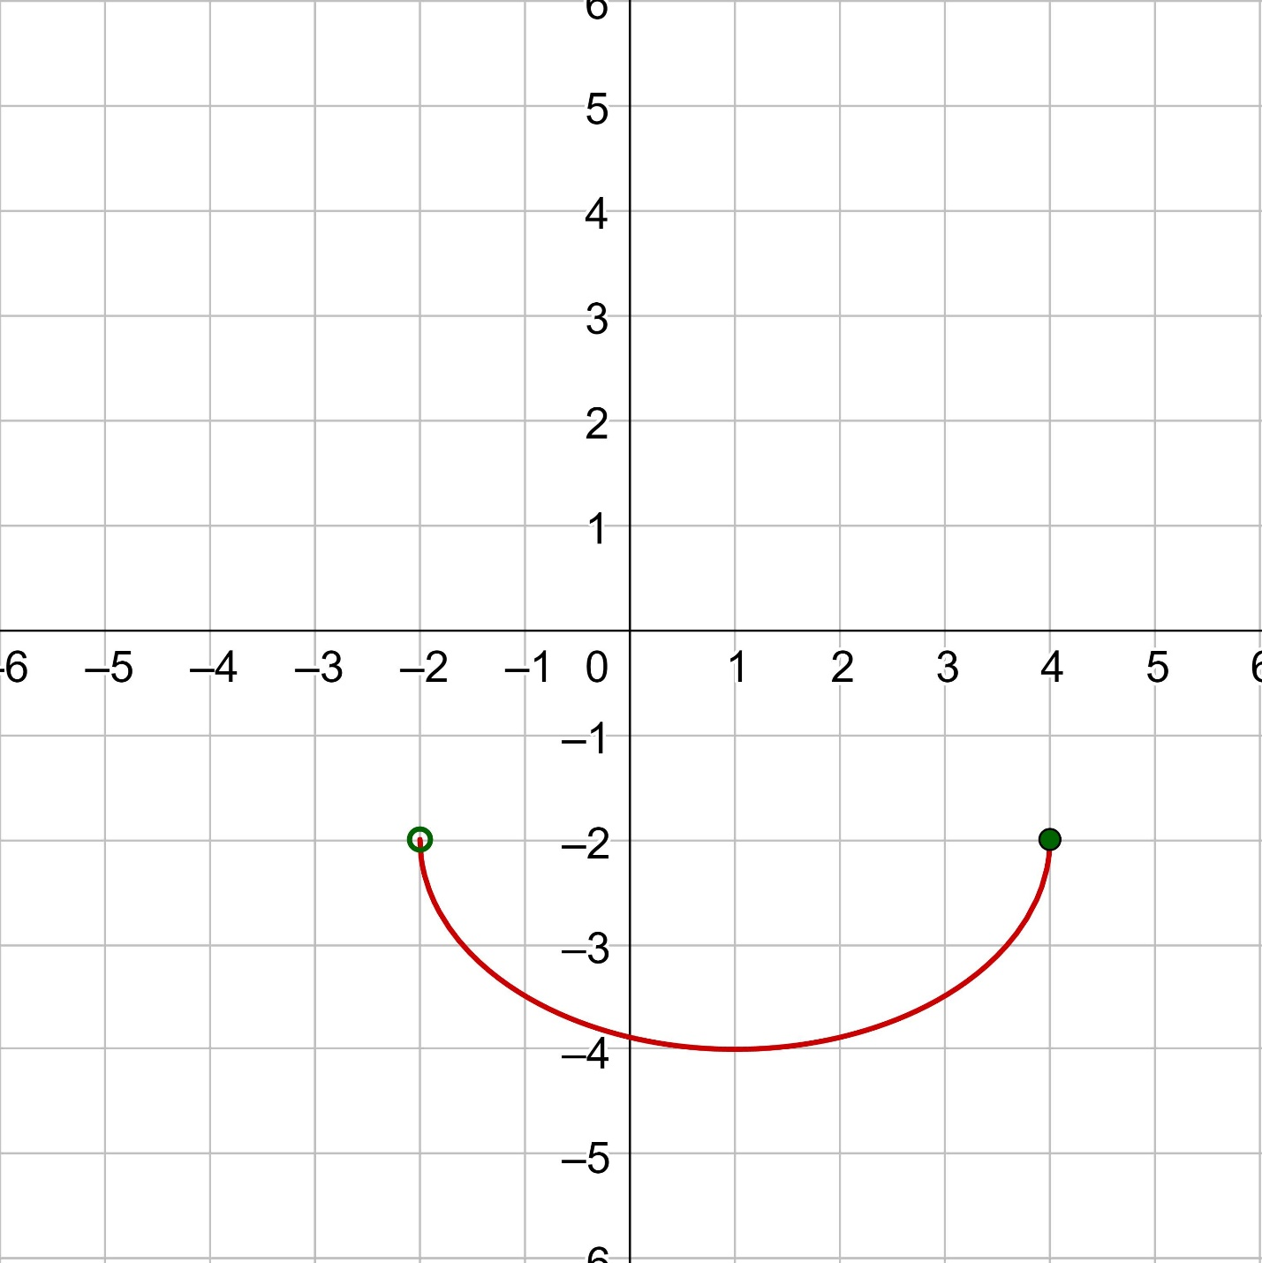
An Open Coordinate Path is a path represented in a coordinate system with distinct endpoints.
Example
$$y=x^{2}, -1≤x≤2.$$
The endpoints are:
$$\left(- , 11\right)$$
and
$$\left(2 , 4\right).$$
Since they are different, the path is open.

9. Open Vector-Defined Path
# Source: AI Source: Provided by: [Data Path: Persons Table -> ID Column: 1, Name_En Column: Motasem Essam] -> From: [ChatGPT] on [7/25/2026]
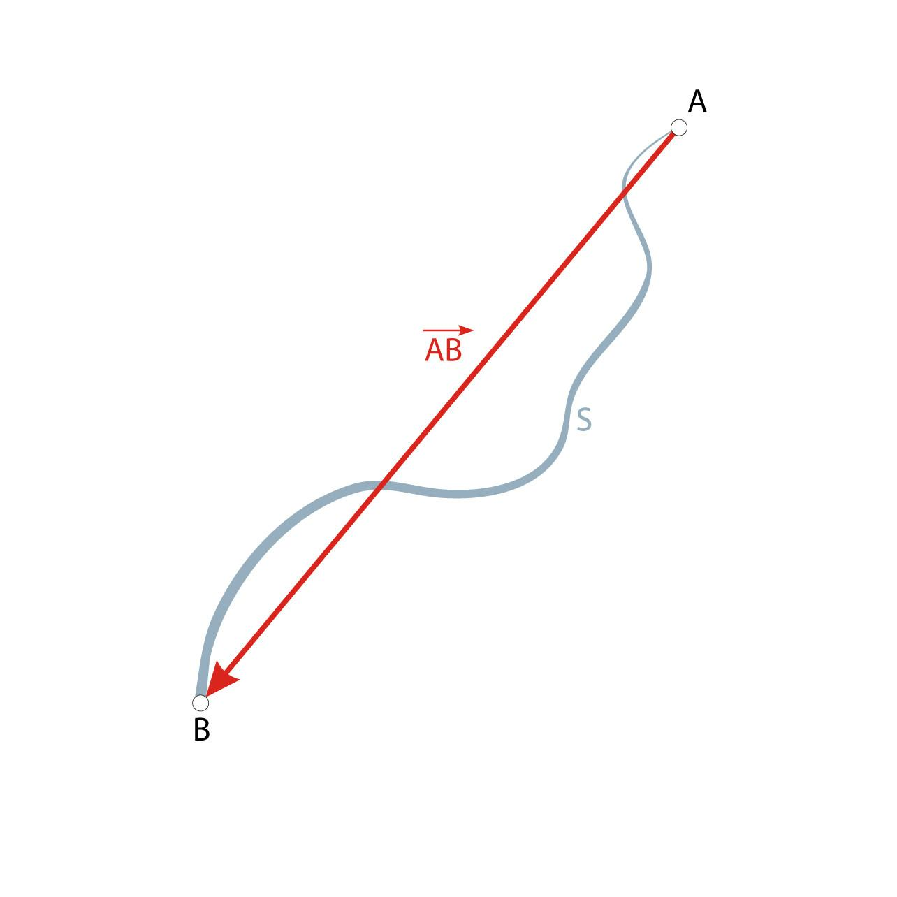
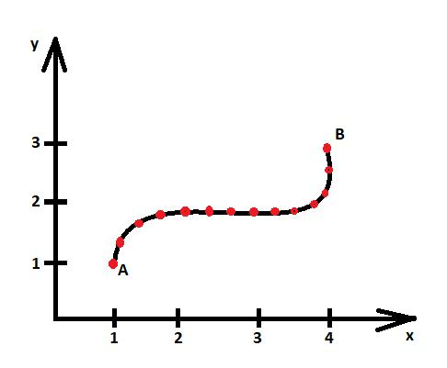
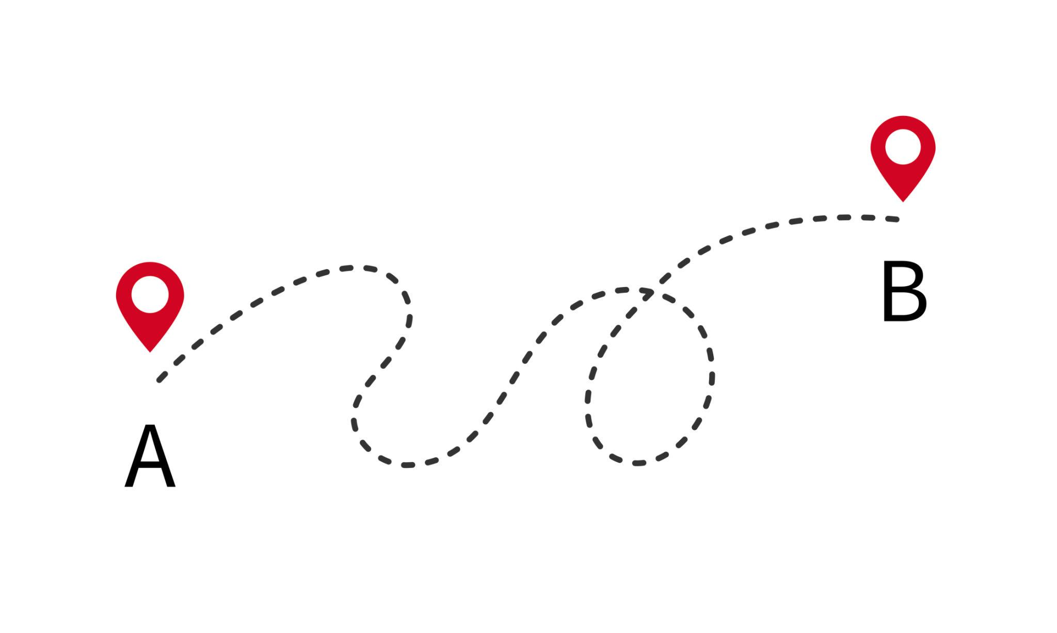
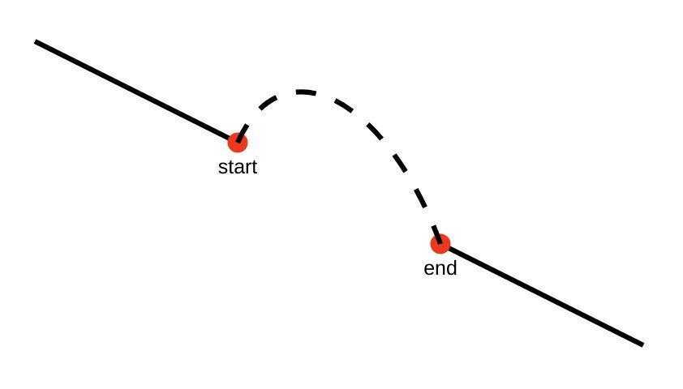
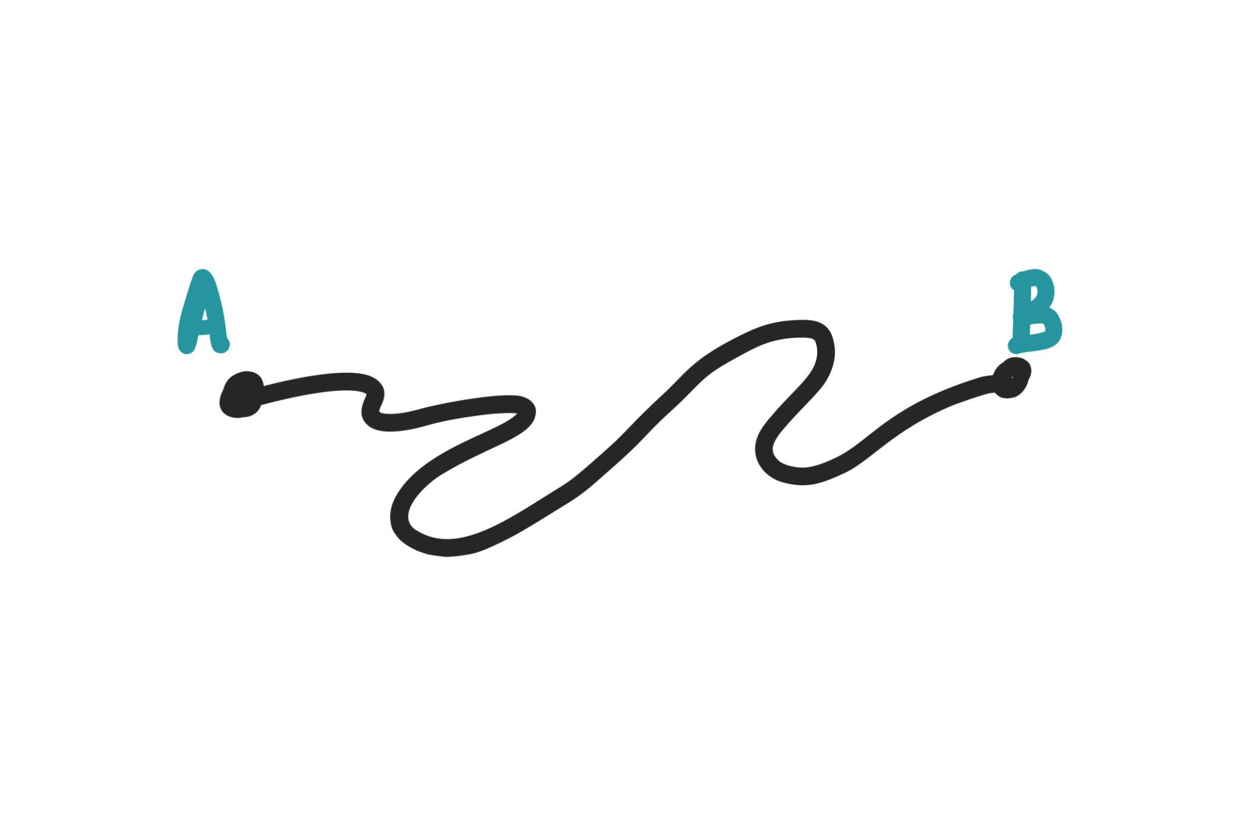
An Open Vector-Defined Path is described by a vector-valued function with different initial and final vectors.
$$\boxed{r\left(a\right)≠r\left(b\right)}$$
Example
$$r\left(t\right)=\left\langle 2 , t3t\right\rangle , 0≤t≤1.$$
Then:
$$r\left(0\right)=\left(0 , 0\right)$$
and
$$r\left(1\right)=\left(2 , 3\right).$$
Thus the path is open.

10. Open Spiral Path
# Source: AI Source: Provided by: [Data Path: Persons Table -> ID Column: 1, Name_En Column: Motasem Essam] -> From: [ChatGPT] on [7/25/2026]
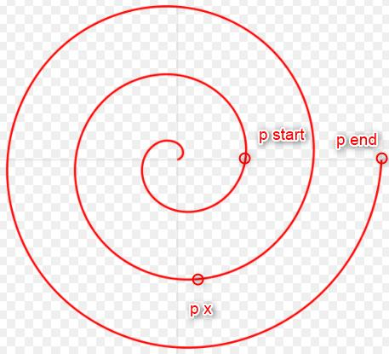
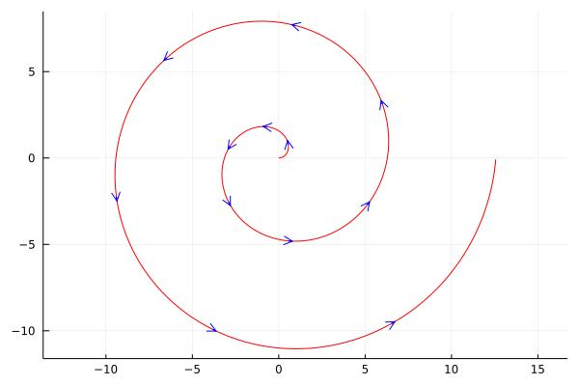
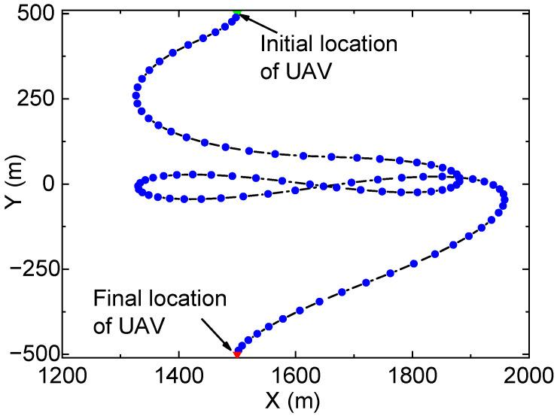
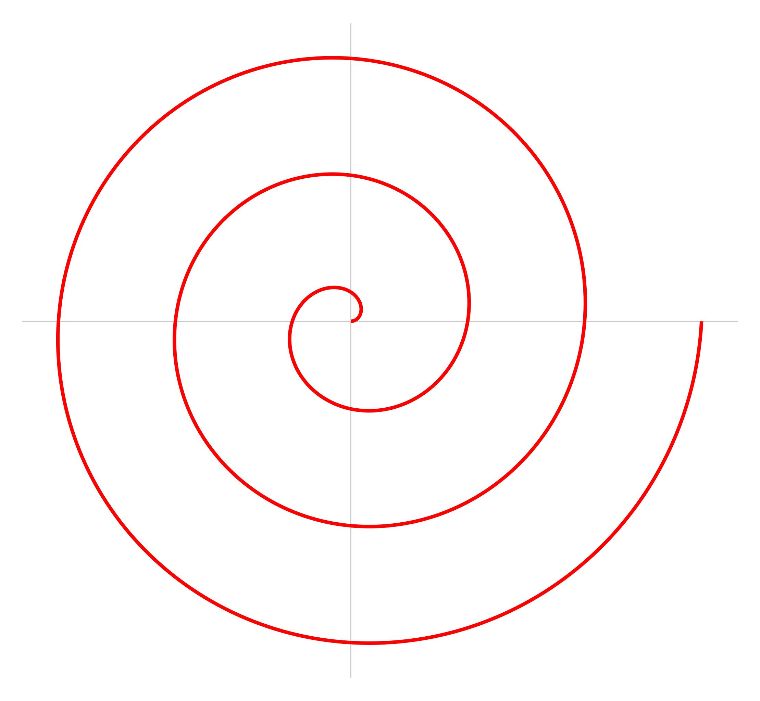
An Open Spiral Path follows a spiral without returning to its starting point.
For an Archimedean spiral:
$$r=aθ.$$
A restricted interval such as
$$0≤θ≤4π$$
produces an open spiral path.
Example
$$x=t\cos{t}, y=t\sin{t}, 0≤t≤4π.$$
The endpoint is different from the starting point.

11. Open Elliptical Path
# Source: AI Source: Provided by: [Data Path: Persons Table -> ID Column: 1, Name_En Column: Motasem Essam] -> From: [ChatGPT] on [7/25/2026]
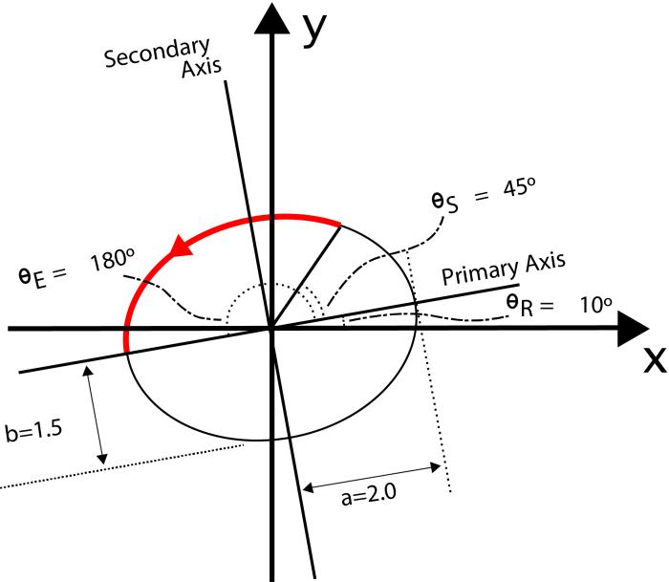
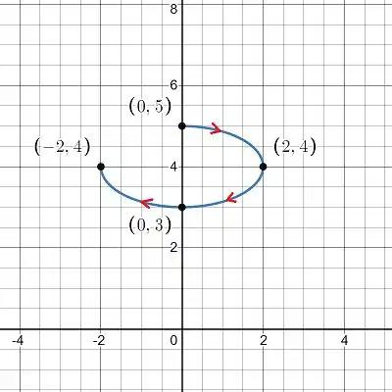
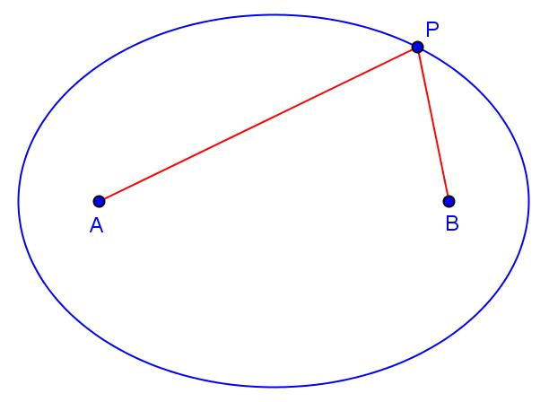
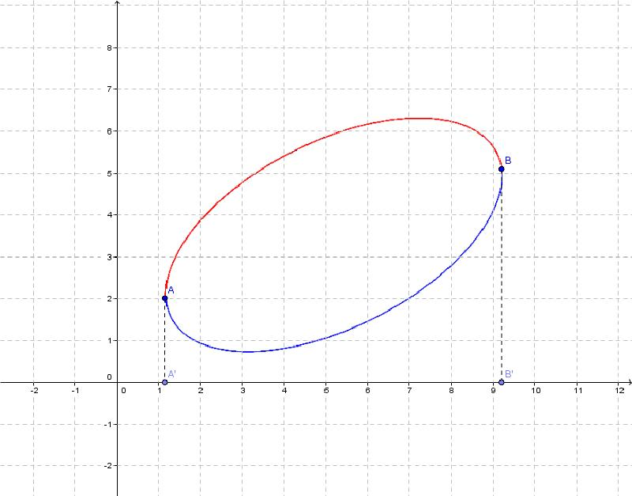
An Open Elliptical Path is a portion of an ellipse with distinct endpoints.
A complete ellipse is closed, but an elliptical arc can be open.
Example
$$x=4\cos{t}, y=2\sin{t},$$
with
$$0≤t≤π.$$
This traces only half of the ellipse and has different endpoints.

12. Open Parabolic Path
# Source: AI Source: Provided by: [Data Path: Persons Table -> ID Column: 1, Name_En Column: Motasem Essam] -> From: [ChatGPT] on [7/25/2026]
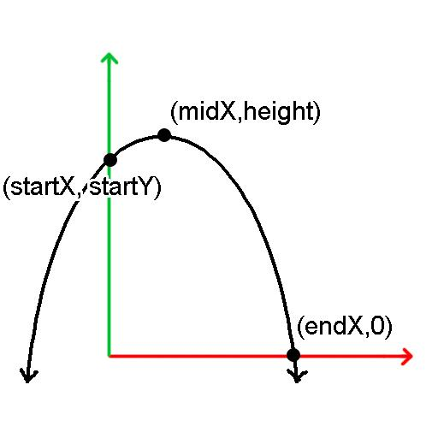
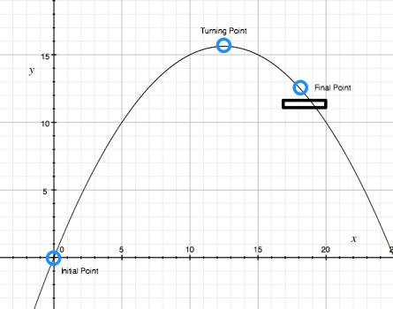
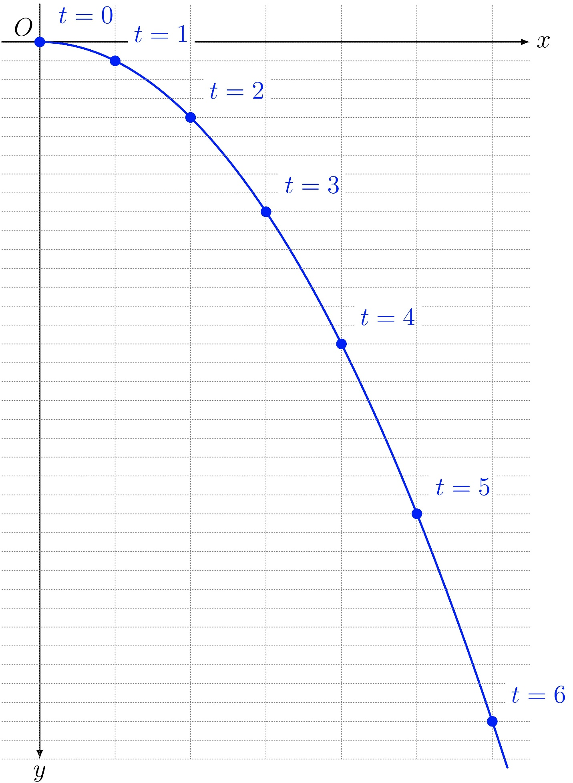
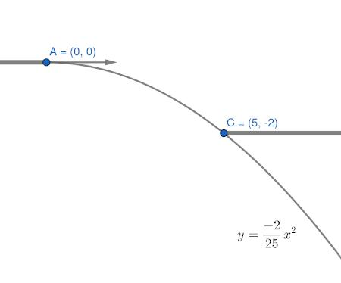
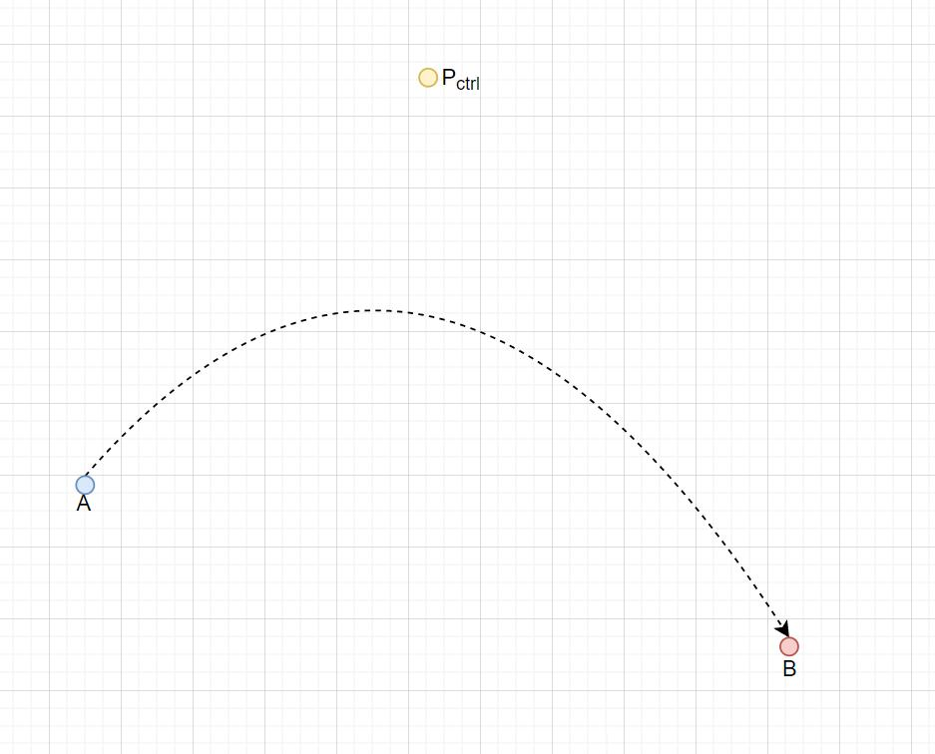
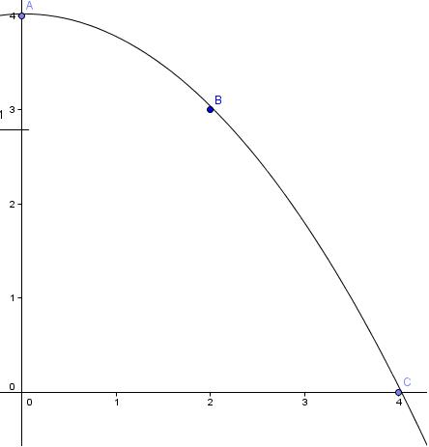
A Parabola itself is an unbounded open curve, and a finite portion of it also forms an open path when its endpoints are distinct.
Example
$$x=t, y=t^{2}, 0≤t≤3.$$
The endpoints are:
$$\left(0 , 0\right)$$
and
$$\left(3 , 9\right).$$
Therefore:
$$\boxed{P_{\text{start}}≠P_{\text{end}}}$$

13. Open Hyperbolic Path
# Source: AI Source: Provided by: [Data Path: Persons Table -> ID Column: 1, Name_En Column: Motasem Essam] -> From: [ChatGPT] on [7/25/2026]
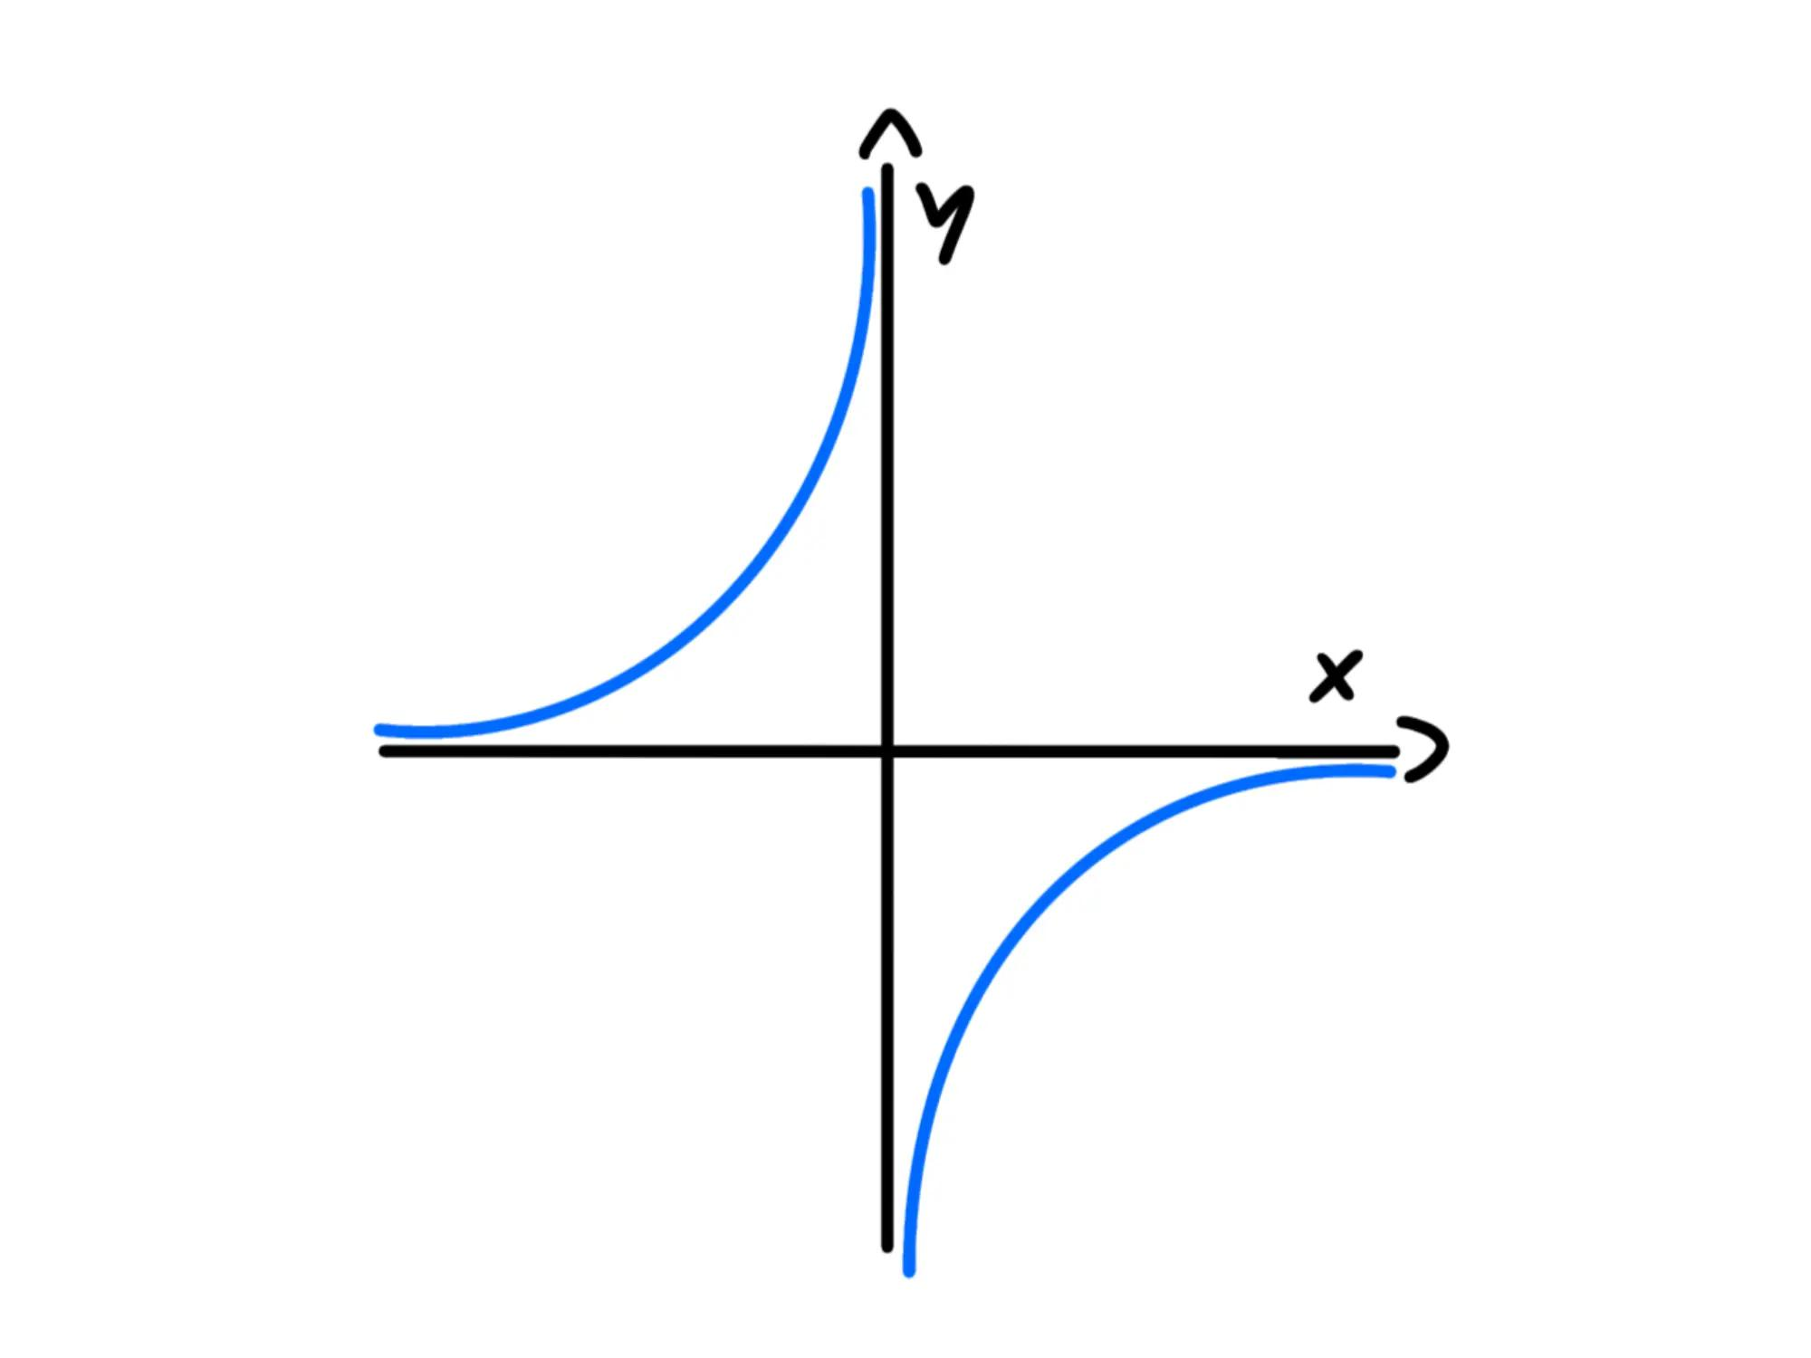
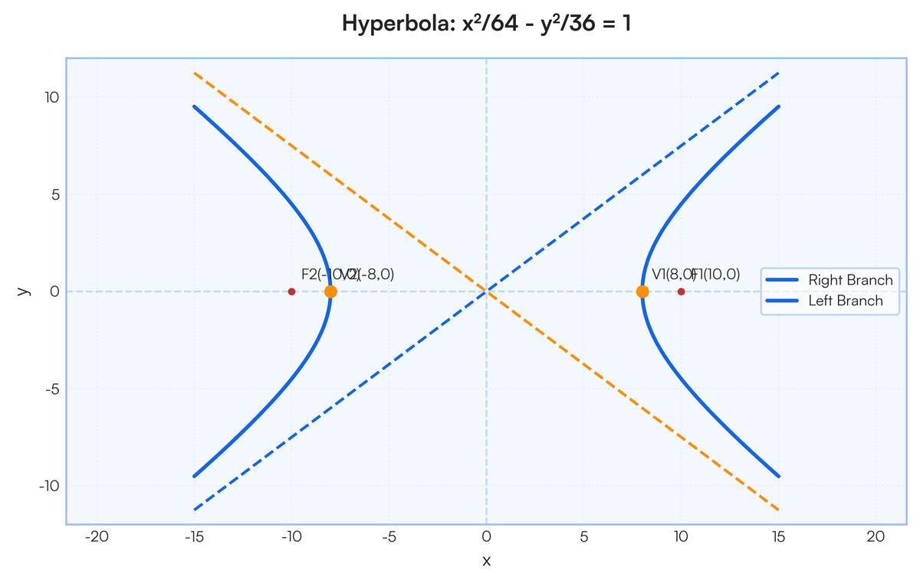
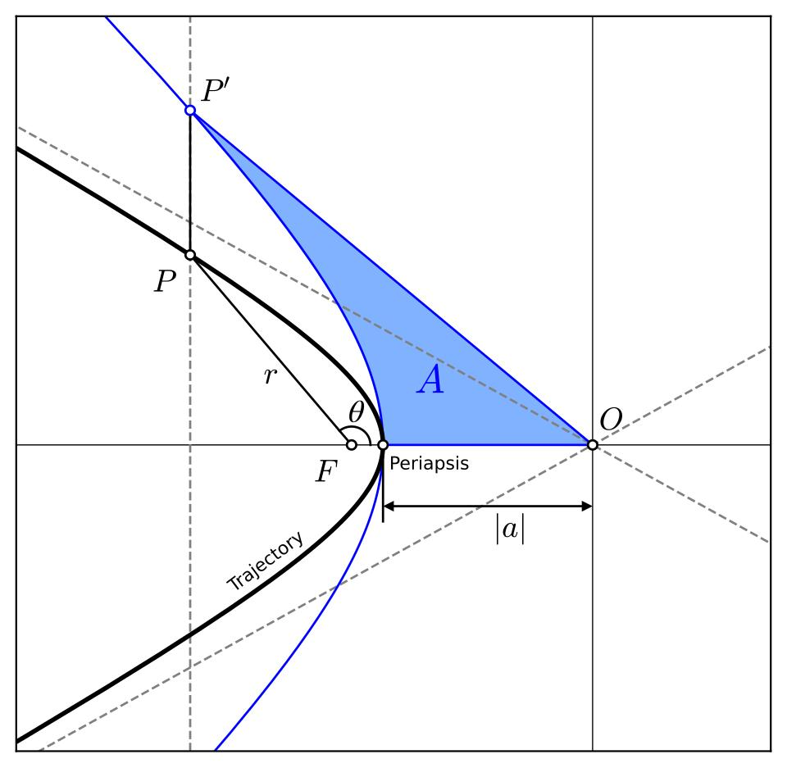
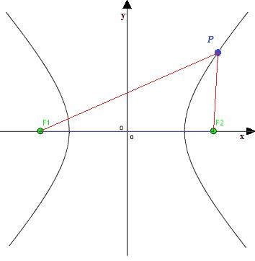
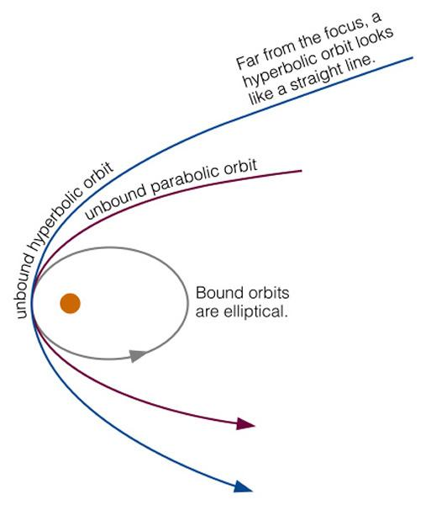
An Open Hyperbolic Path follows a branch or portion of a hyperbola.
For example:
$$\frac{x^{2}}{9}-\frac{y^{2}}{4}=1.$$
A finite section of one branch forms an open path.
Example
A point moves along the right branch from one point to another without returning to its starting point.

14. Simple Open Path
# Source: AI Source: Provided by: [Data Path: Persons Table -> ID Column: 1, Name_En Column: Motasem Essam] -> From: [ChatGPT] on [7/25/2026]
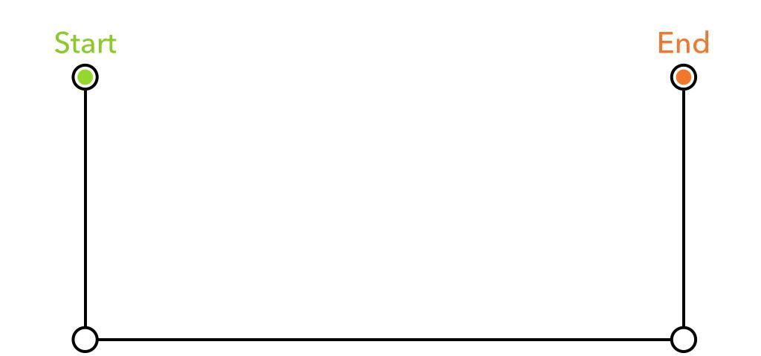
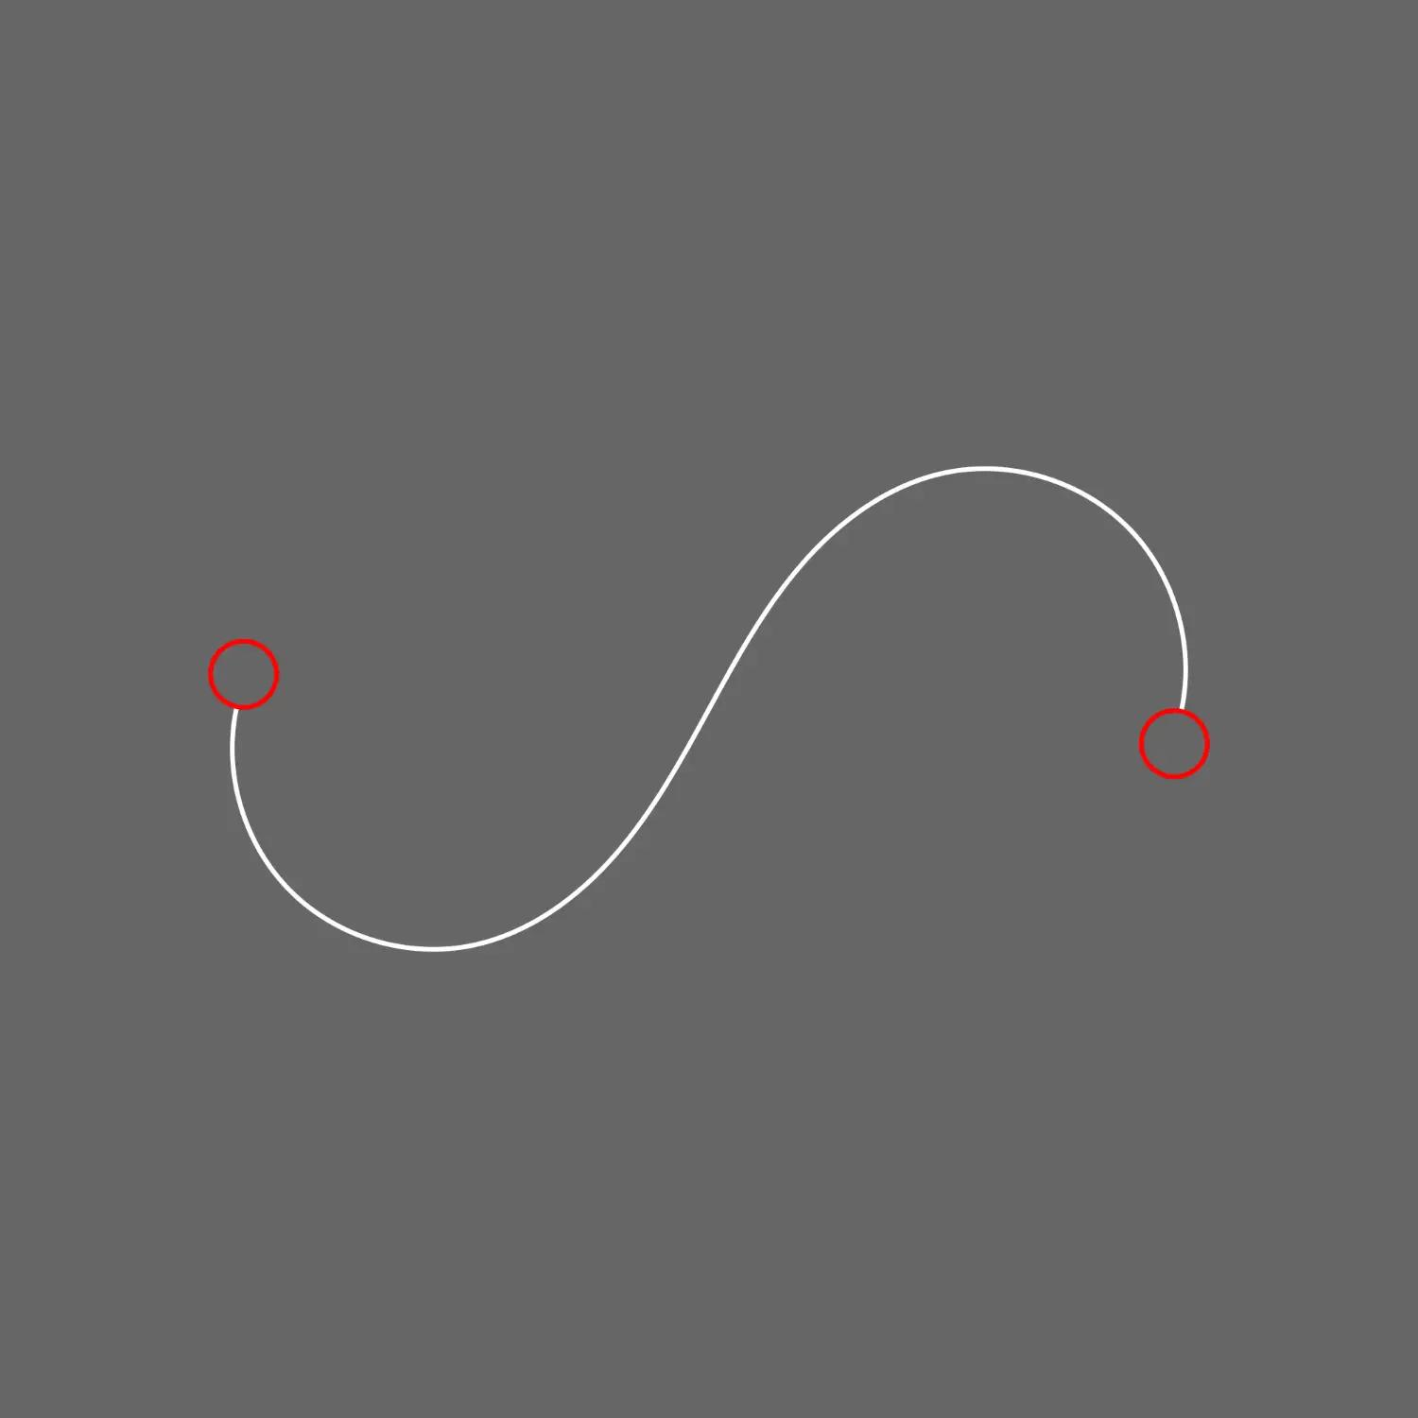
A Simple Open Path has distinct endpoints and does not intersect itself.
Thus:
$$\boxed{A≠B}$$
and there are no self-intersections.
Example
A simple arc from $A$to $B$is a simple open path.

15. Self-Intersecting Open Path
# Source: AI Source: Provided by: [Data Path: Persons Table -> ID Column: 1, Name_En Column: Motasem Essam] -> From: [ChatGPT] on [7/25/2026]
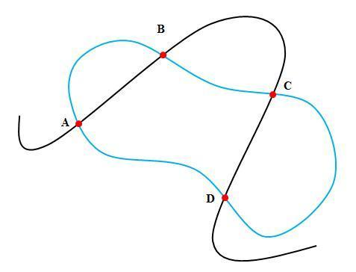
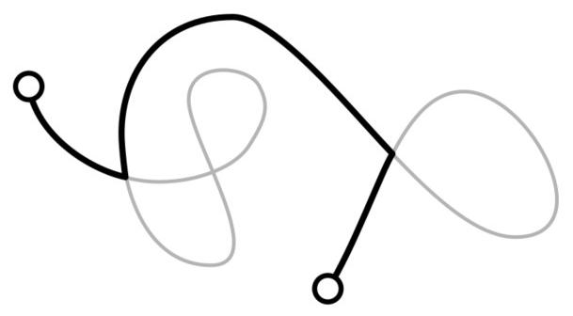
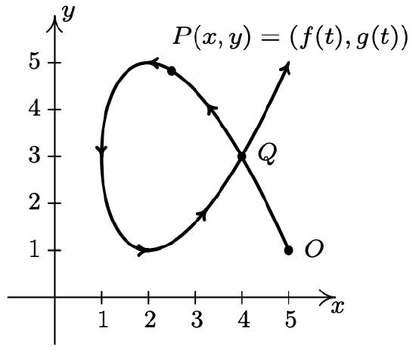
A Self-Intersecting Open Path has different endpoints but crosses itself at one or more points.
It satisfies:
$$\boxed{P_{\text{start}}≠P_{\text{end}}}$$
while there exist distinct parameter values such that
$$\boxed{r\left(t_{1}\right)=r\left(t_{2}\right), t_{1}≠t_{2}}.$$
Example
An open figure-eight-shaped curve that begins at $A$and ends at $B$can cross itself in the middle.

16. Smooth Open Path
# Source: AI Source: Provided by: [Data Path: Persons Table -> ID Column: 1, Name_En Column: Motasem Essam] -> From: [ChatGPT] on [7/25/2026]
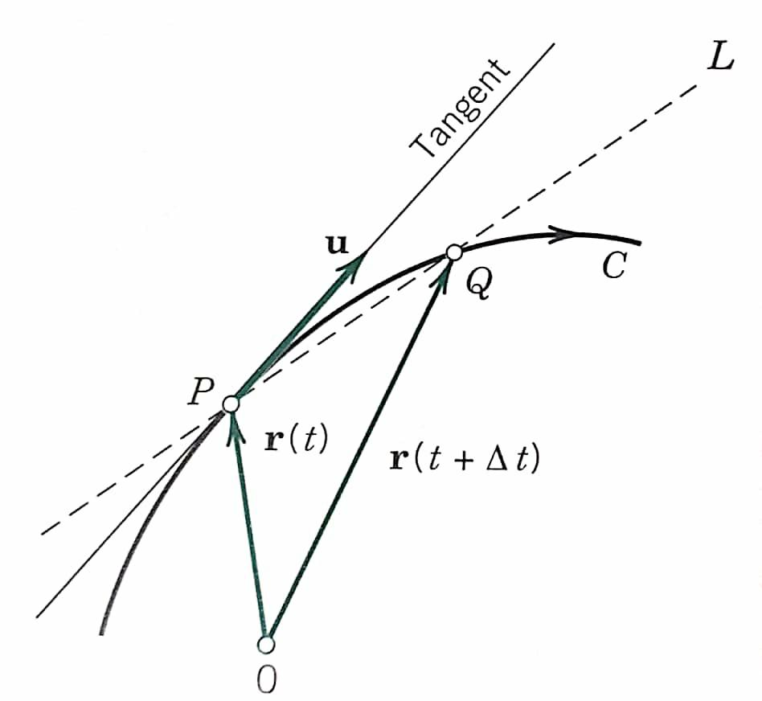
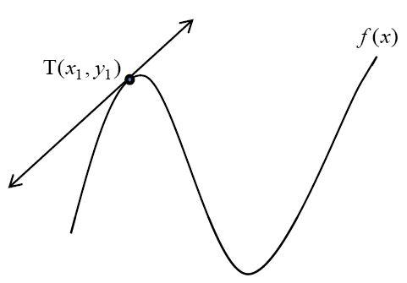
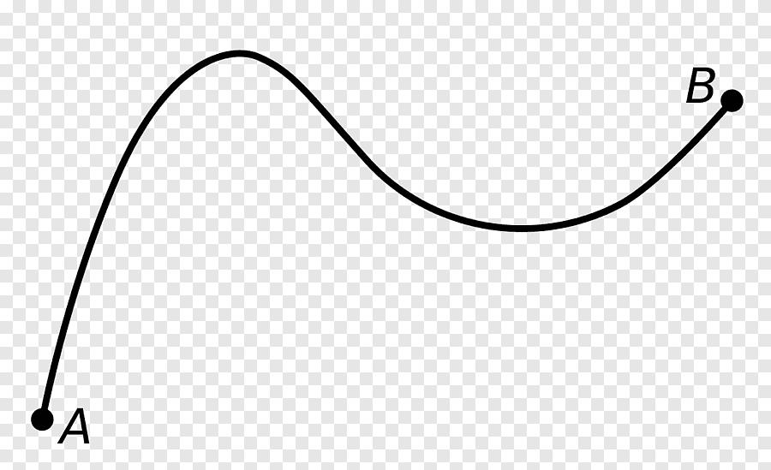
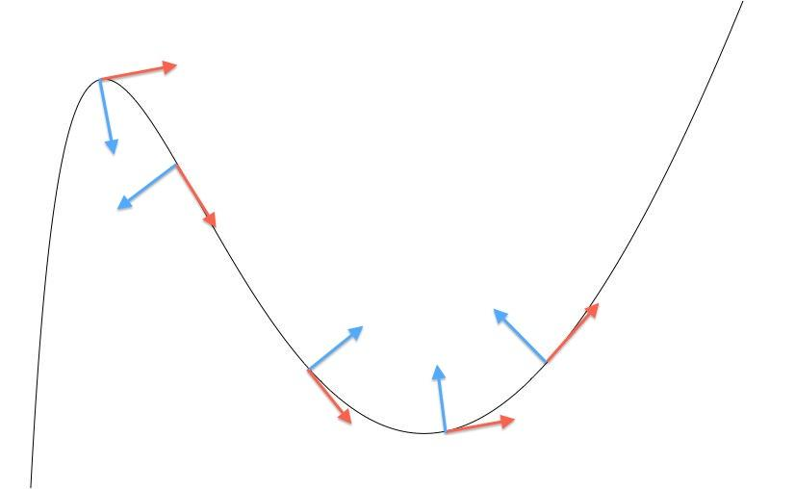
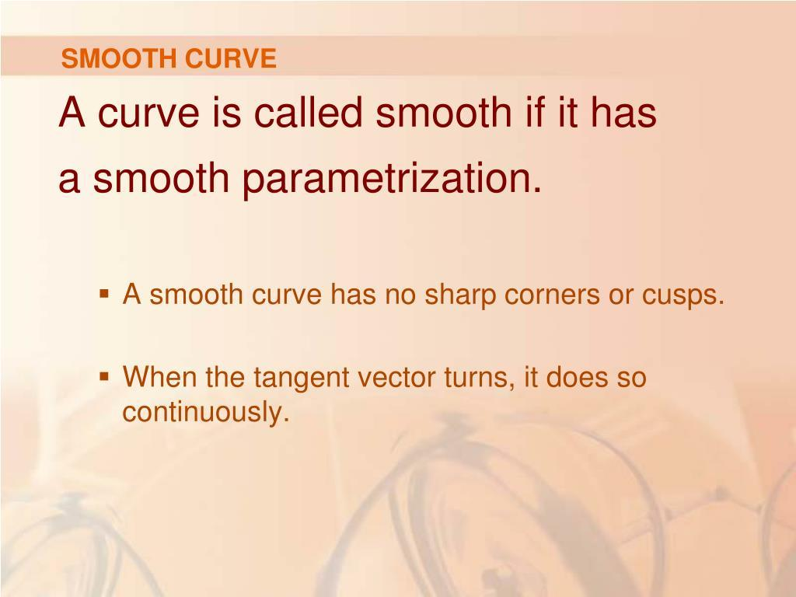
A Smooth Open Path has distinct endpoints and no abrupt changes in tangent direction along the path.
For a differentiable parametrization:
$$r^{'}\left(t\right)$$
exists and varies continuously over the relevant interval.
Example
A parabolic arc from $A$to $B$is a smooth open path.

17. Non-Smooth Open Path
# Source: AI Source: Provided by: [Data Path: Persons Table -> ID Column: 1, Name_En Column: Motasem Essam] -> From: [ChatGPT] on [7/25/2026]
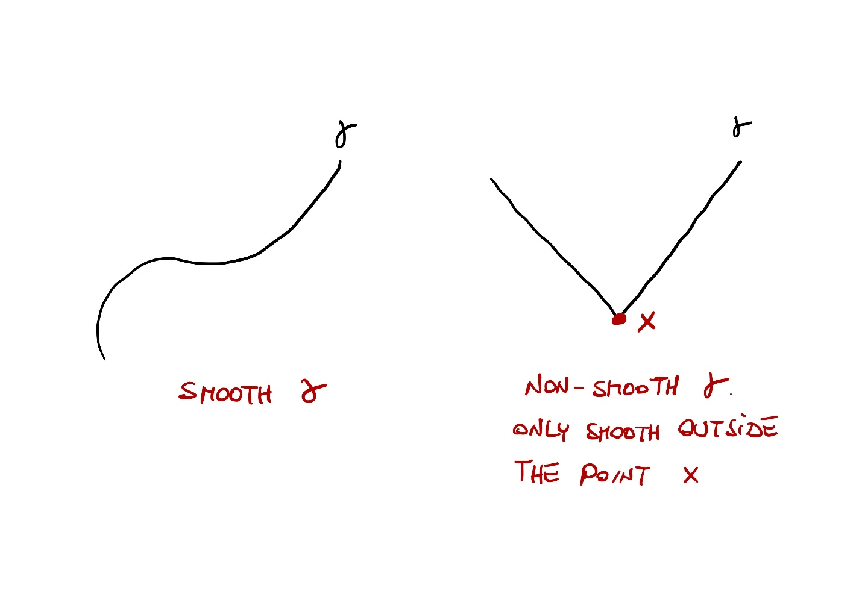
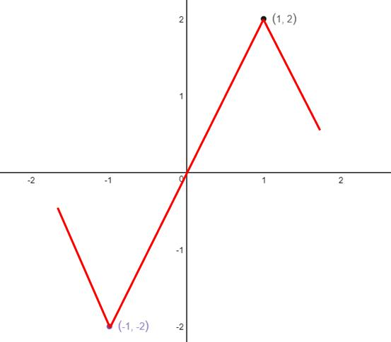
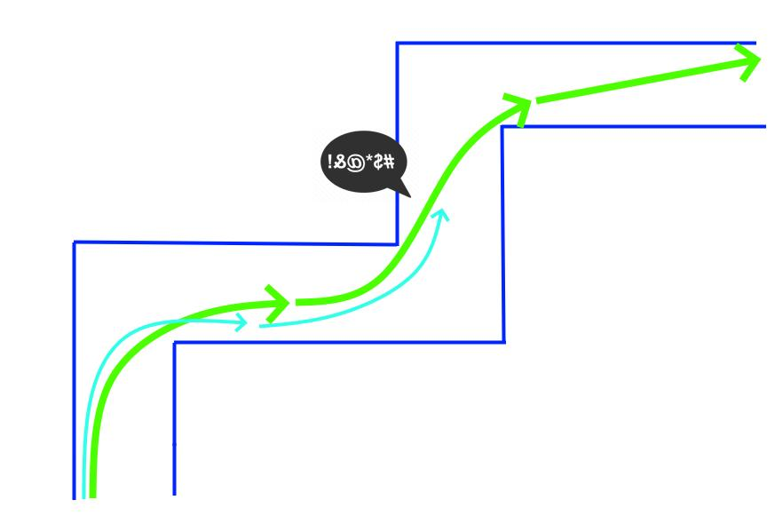
A Non-Smooth Open Path has different endpoints but contains at least one sharp corner or other non-smooth point.
Example
$$A→B→C$$
where $AB$and $BC$are straight segments meeting at a non-${180}^{∘}$ angle.
The path is:
- open,
- continuous,
- non-smooth.
Important Relationship
$$\boxed{\text{Smooth}⇒\text{Continuous}}$$
but
$$\boxed{\text{Continuous}⇏\text{Smooth}}.$$

18. Restricted Open Path
# Source: AI Source: Provided by: [Data Path: Persons Table -> ID Column: 1, Name_En Column: Motasem Essam] -> From: [ChatGPT] on [7/25/2026]
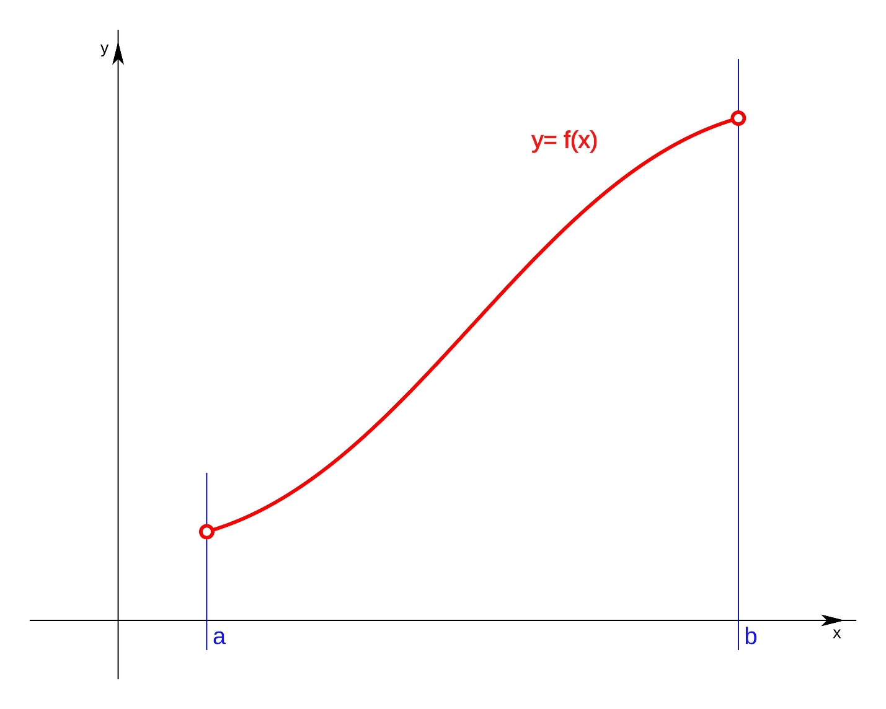
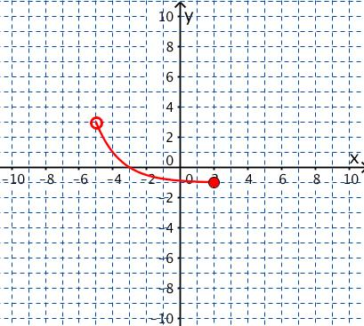
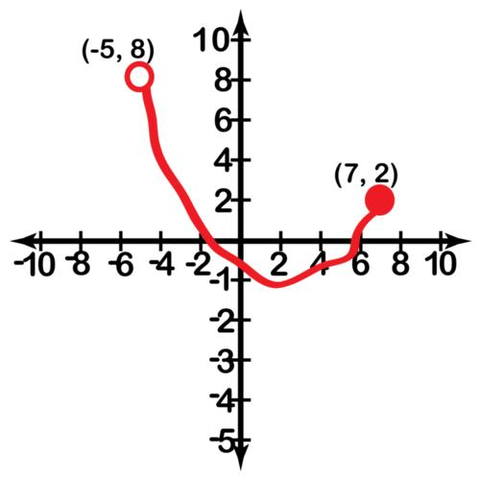
A Restricted Open Path is an open path obtained by imposing restrictions on an otherwise larger path.
Example
For the circle
$$x^{2}+y^{2}=25,$$
restrict the angular parameter to
$$0<t<π.$$
This selects an open portion of the circular path.
Another example:
$$y=x^{2}, 0≤x≤4.$$

19. Monotone Open Path
# Source: AI Source: Provided by: [Data Path: Persons Table -> ID Column: 1, Name_En Column: Motasem Essam] -> From: [ChatGPT] on [7/25/2026]
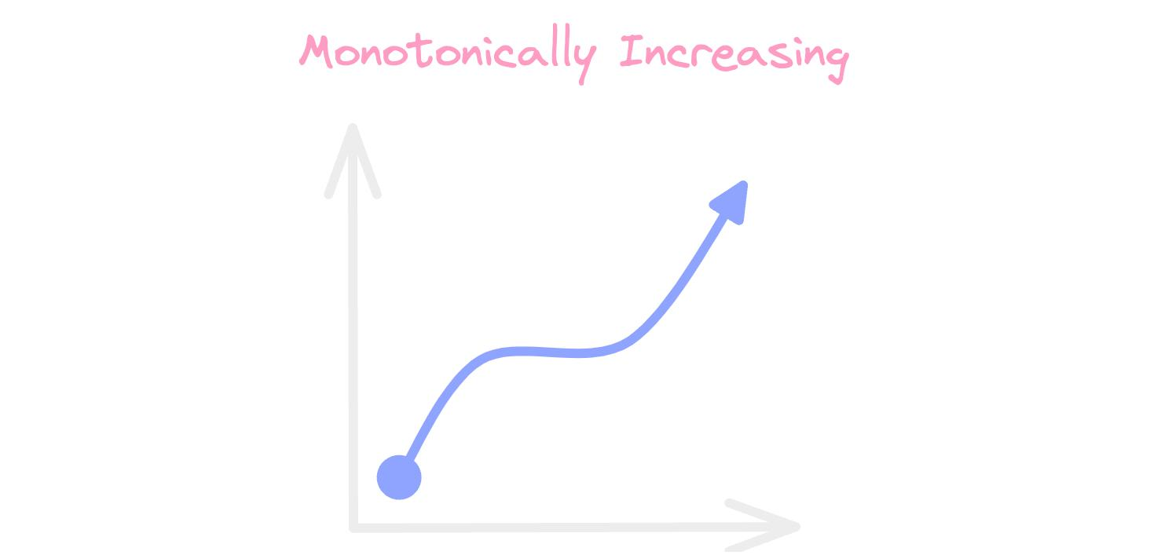
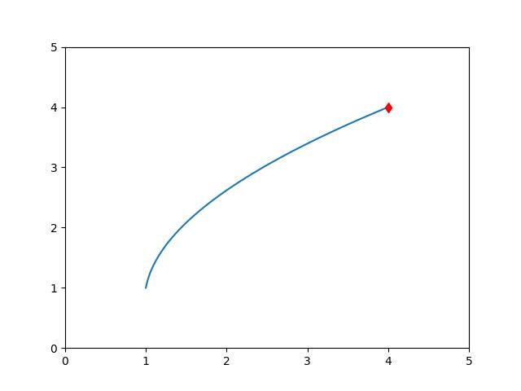
A Monotone Open Path has distinct endpoints and progresses consistently in a particular coordinate direction.
For an $x$-monotone path:
$$t_{2}>t_{1} ⇒ x\left(t_{2}\right)≥x\left(t_{1}\right).$$
Example
$$x=t, y=t^{2}, 0≤t≤3.$$
Here $x$continually increases from $0$to $3$.

20. Combined Open Path
# Source: AI Source: Provided by: [Data Path: Persons Table -> ID Column: 1, Name_En Column: Motasem Essam] -> From: [ChatGPT] on [7/25/2026]
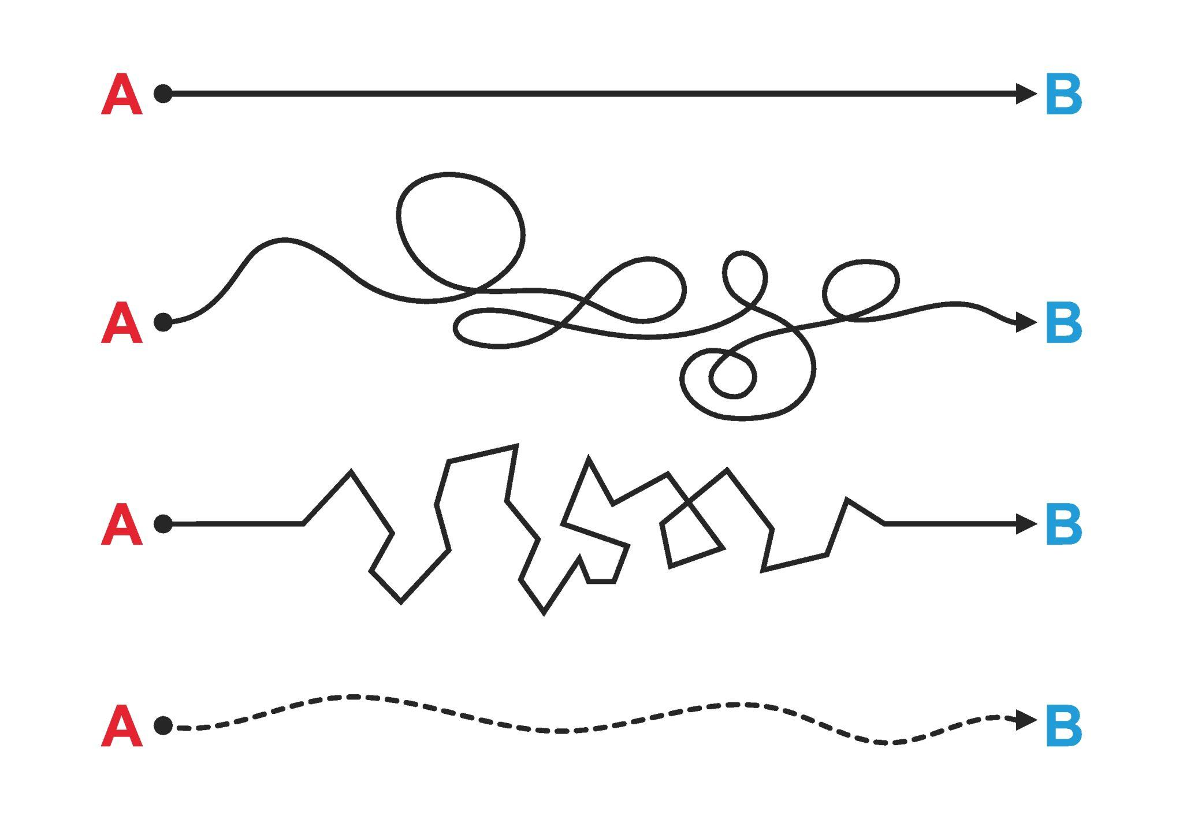
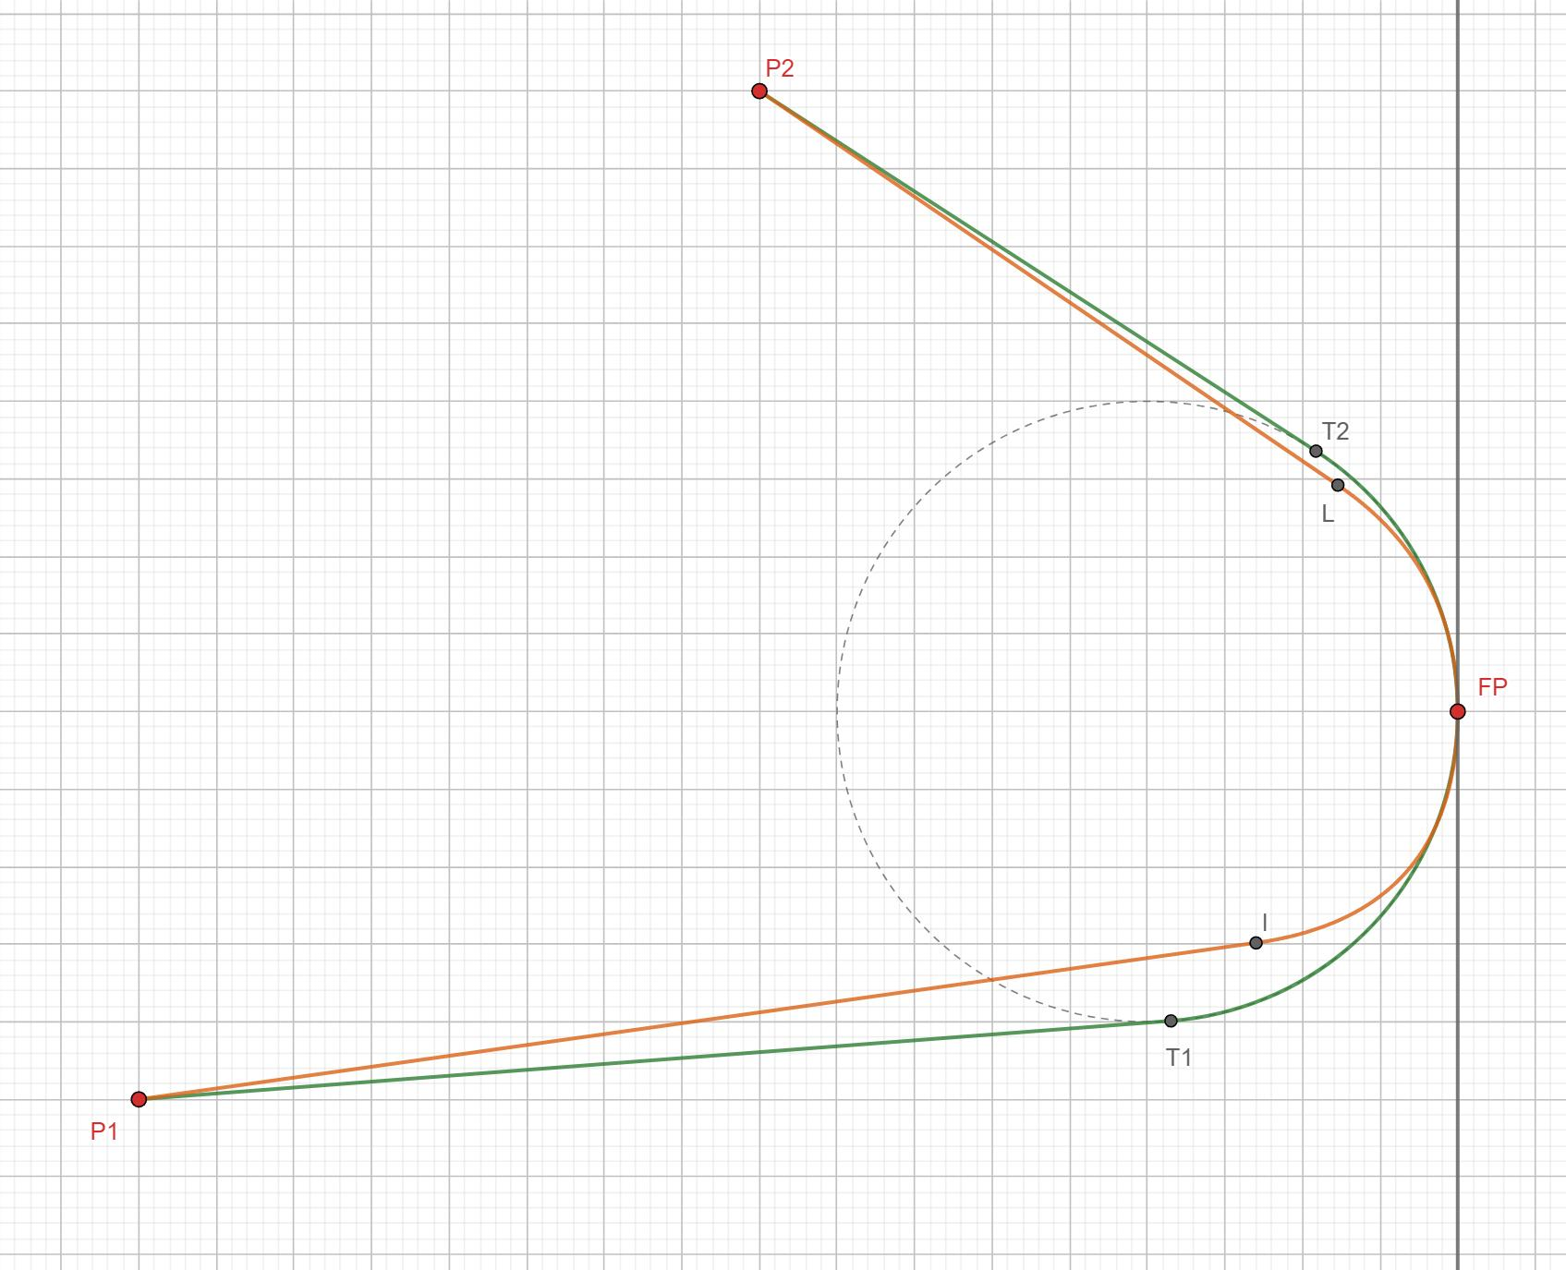
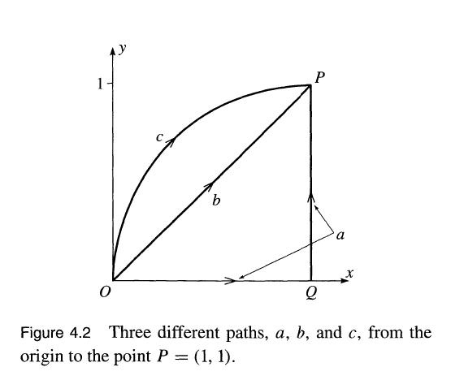
A Combined Open Path contains multiple types of path pieces while maintaining distinct starting and ending points.
For example:
$$\boxed{\text{Straight}→\text{Circular Arc}→\text{Parabolic Arc}}$$
with
$$A≠B$$
for the overall starting and ending points.

4. Fundamental Condition for an Open Path
# Source: AI Source: Provided by: [Data Path: Persons Table -> ID Column: 1, Name_En Column: Motasem Essam] -> From: [ChatGPT] on [7/25/2026]
The defining condition is:
$$\boxed{P_{\text{start}}≠P_{\text{end}}}$$
For a parameterized path:
$$\boxed{r\left(a\right)≠r\left(b\right)}$$
For a polygonal path:
$$\boxed{P_{0}≠P_{n}}$$
This condition is more fundamental than the particular shape of the path.

5. Open Path and Closed Path
# Source: AI Source: Provided by: [Data Path: Persons Table -> ID Column: 1, Name_En Column: Motasem Essam] -> From: [ChatGPT] on [7/25/2026]
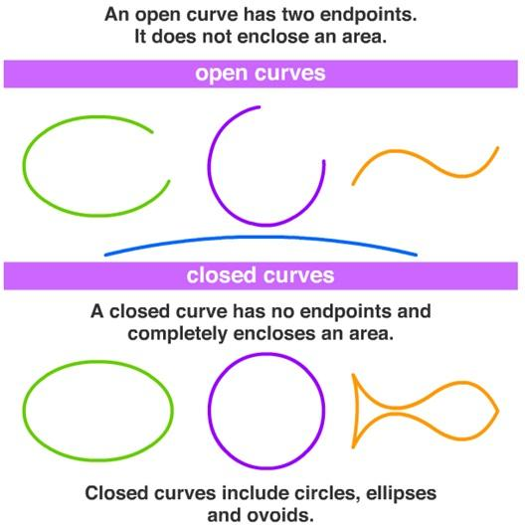
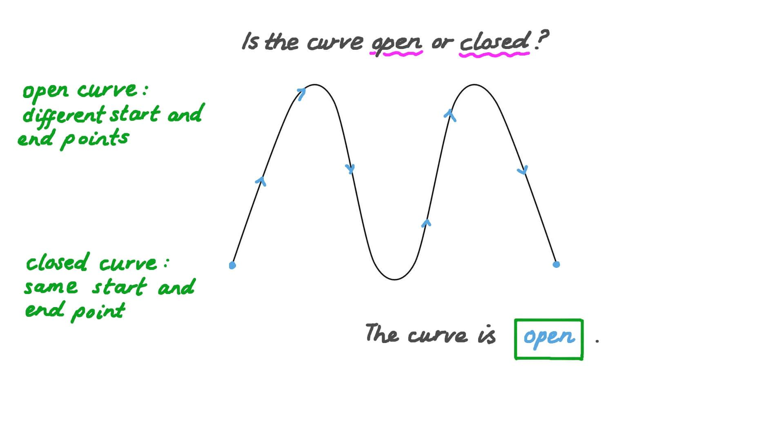
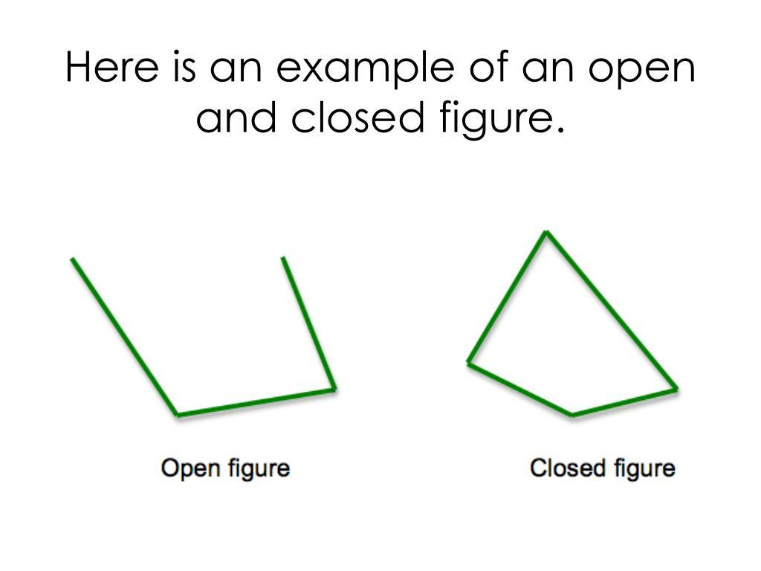
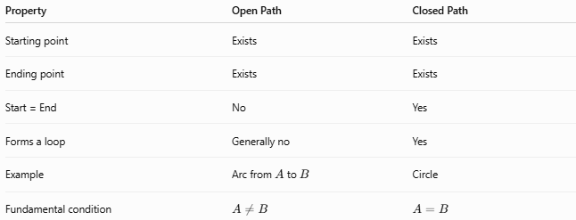
Property | Open Path | Closed Path
Starting point | Exists | Exists
Ending point | Exists | Exists
Start = End | No | Yes
Forms a loop | Generally no | Yes
Example | Arc from $A$to $B$ | Circle
Fundamental condition | $$A≠B$$ | $$A=B$$
Thus:
$$\boxed{\text{Open Path }⟺ P_{\text{start}}≠P_{\text{end}}}$$
and
$$\boxed{\text{Closed Path }⟺ P_{\text{start}}=P_{\text{end}}}.$$

6. Open Path Does Not Mean Straight
# Source: AI Source: Provided by: [Data Path: Persons Table -> ID Column: 1, Name_En Column: Motasem Essam] -> From: [ChatGPT] on [7/25/2026]
An important distinction is that open describes the relationship between the endpoints, not the shape.
An open path can be:
- straight,
- circular,
- elliptical,
- parabolic,
- polygonal,
- spiral,
- piecewise,
- self-intersecting,
- smooth,
- non-smooth.
For example:
$$\boxed{\text{Open Path}≠\text{Straight Path}}$$
Instead, these are different classifications.
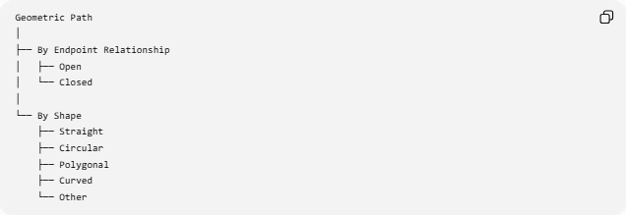
Geometric Path
│
├── By Endpoint Relationship
│ ├── Open
│ └── Closed
│
└── By Shape
├── Straight
├── Circular
├── Polygonal
├── Curved
└── Other

7. Open Path and Simple Path
# Source: AI Source: Provided by: [Data Path: Persons Table -> ID Column: 1, Name_En Column: Motasem Essam] -> From: [ChatGPT] on [7/25/2026]
These properties are also independent.
An open path can be:
Simple Open Path
No self-intersection.
Self-Intersecting Open Path
Has one or more self-intersections.
Therefore:
$$\boxed{\text{Open}⇏\text{Simple}}$$
and
$$\boxed{\text{Open}⇏\text{Non-Self-Intersecting}}$$

8. Open Path and Smoothness
# Source: AI Source: Provided by: [Data Path: Persons Table -> ID Column: 1, Name_En Column: Motasem Essam] -> From: [ChatGPT] on [7/25/2026]
Similarly, an open path can be smooth or non-smooth.
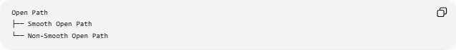
Open Path
├── Smooth Open Path
└── Non-Smooth Open Path
For example:
- parabolic arc → smooth open path
- two line segments meeting at a corner → non-smooth open path.

9. Length of an Open Path
# Source: AI Source: Provided by: [Data Path: Persons Table -> ID Column: 1, Name_En Column: Motasem Essam] -> From: [ChatGPT] on [7/25/2026]
For a parameterized path
$$r\left(t\right)=\left\langle x , \left(t\right)y\left(t\right)\right\rangle , a≤t≤b,$$
its length is
$$\boxed{L=\int_{a}^{b}{\sqrt{x^{'}{\left(t\right)}^{2}+y^{'}{\left(t\right)}^{2}}} dt}$$
For a polygonal open path:
$$\boxed{L=\sum_{i=0}^{n-1}{∣}P_{i}P_{i+1}∣}$$
For an open path from $A$to $B$, the direct distance satisfies
$$\boxed{AB≤L}.$$
Equality occurs when the path is the straight segment from $A$to $B$.

10. Open Path in Three Dimensions
# Source: AI Source: Provided by: [Data Path: Persons Table -> ID Column: 1, Name_En Column: Motasem Essam] -> From: [ChatGPT] on [7/25/2026]
An open path can also exist in three-dimensional space.
$$\boxed{r\left(t\right)=\left\langle x , \left(t\right) , y\left(t\right)z\left(t\right)\right\rangle }$$
with
$$\boxed{r\left(a\right)≠r\left(b\right)}.$$
Example
A helical segment:
$$x=\cos{t}, \\ y=\sin{t}, \\ z=t, 0≤t≤2π.$$
The path begins at
$$\left(1 , 0 , 0\right)$$
and ends at
$$\left(1 , 0 , 2π\right),$$
so it is open.

11. Relationship with Loci
# Source: AI Source: Provided by: [Data Path: Persons Table -> ID Column: 1, Name_En Column: Motasem Essam] -> From: [ChatGPT] on [7/25/2026]
An open path can result from restricting a locus.
For example, the complete circle
$${\left(x-h\right)}^{2}+{\left(y-k\right)}^{2}=r^{2}$$
is closed.
But restricting its parameter to
$$0≤t≤π$$
produces a semicircular path whose endpoints are distinct.
Thus:
$$\boxed{\text{Complete Locus}→\text{Restriction}→\text{Open Path}}$$

12. Classification Summary
# Source: AI Source: Provided by: [Data Path: Persons Table -> ID Column: 1, Name_En Column: Motasem Essam] -> From: [ChatGPT] on [7/25/2026]
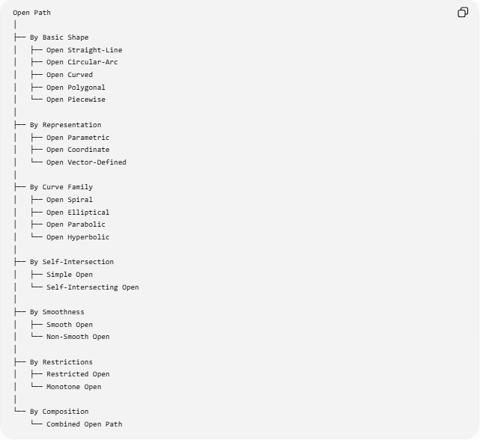
Open Path
│
├── By Basic Shape
│ ├── Open Straight-Line
│ ├── Open Circular-Arc
│ ├── Open Curved
│ ├── Open Polygonal
│ └── Open Piecewise
│
├── By Representation
│ ├── Open Parametric
│ ├── Open Coordinate
│ └── Open Vector-Defined
│
├── By Curve Family
│ ├── Open Spiral
│ ├── Open Elliptical
│ ├── Open Parabolic
│ └── Open Hyperbolic
│
├── By Self-Intersection
│ ├── Simple Open
│ └── Self-Intersecting Open
│
├── By Smoothness
│ ├── Smooth Open
│ └── Non-Smooth Open
│
├── By Restrictions
│ ├── Restricted Open
│ └── Monotone Open
│
└── By Composition
└── Combined Open Path

13. Key Formulas
# Source: AI Source: Provided by: [Data Path: Persons Table -> ID Column: 1, Name_En Column: Motasem Essam] -> From: [ChatGPT] on [7/25/2026]
Fundamental Open-Path Condition
$$\boxed{P_{\text{start}}≠P_{\text{end}}}$$
Parametric Form
$$\boxed{r\left(t\right)=\left\langle x , \left(t\right)y\left(t\right)\right\rangle }$$
Open Parametric Condition
$$\boxed{r\left(a\right)≠r\left(b\right)}$$
Open Polygonal Path
$$\boxed{P_{0}≠P_{n}}$$
Polygonal Length
$$\boxed{L=\sum_{i=0}^{n-1}{∣}P_{i}P_{i+1}∣}$$
Parametric Arc Length
$$\boxed{L=\int_{a}^{b}{\sqrt{x^{'}{\left(t\right)}^{2}+y^{'}{\left(t\right)}^{2}}} dt}$$
Endpoint Distance
$$\boxed{AB≤L}$$
Circular Arc
$$\boxed{s=rθ}$$

14. Key Points
# Source: AI Source: Provided by: [Data Path: Persons Table -> ID Column: 1, Name_En Column: Motasem Essam] -> From: [ChatGPT] on [7/25/2026]
- An Open Path has different starting and ending points.
- Its fundamental condition is:
$$P_{\text{start}}≠P_{\text{end}}.$$
- Open describes endpoint relationship, not the geometric shape.
- An open path can be straight, circular, curved, polygonal, spiral, or piecewise.
- An open path can be simple or self-intersecting.
- An open path can be smooth or non-smooth.
- A restricted portion of a closed curve can become an open path.
- A parameterized open path satisfies:
$$r\left(a\right)≠r\left(b\right).$$
- An open polygonal path satisfies:
$$P_{0}≠P_{n}.$$
- An open path generally has a length greater than or equal to the direct distance between its endpoints:
$$L≥AB.$$
- A closed path is characterized by:
$$P_{\text{start}}=P_{\text{end}}.$$
- Open and closed are complementary endpoint classifications for paths.

Conclusion
# Source: AI Source: Provided by: [Data Path: Persons Table -> ID Column: 1, Name_En Column: Motasem Essam] -> From: [ChatGPT] on [7/25/2026]
An Open Path is a geometric path whose starting point and ending point are distinct:
$$\boxed{\text{Open Path }⟺ P_{\text{start}}≠P_{\text{end}}}$$
It is a classification based on the relationship between the endpoints, rather than on the shape of the path. Therefore, open paths can be straight, curved, polygonal, circular-arc, parametric, piecewise, spiral, or three-dimensional.
The most important distinction is:
$$\boxed{\text{Open}→\text{Start and End are Different}}$$
whereas
$$\boxed{\text{Closed}→\text{Start and End are the Same}}$$

